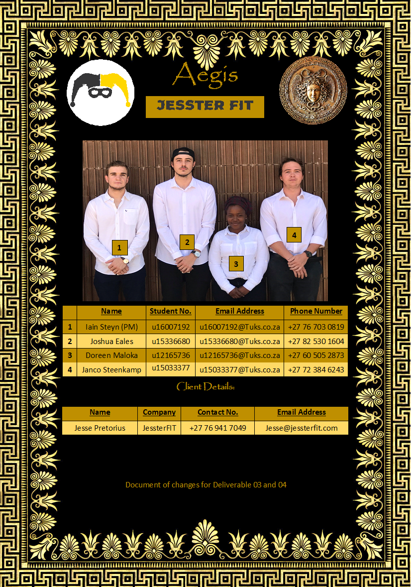

Table of Contents

5 Input Design 3

5.1 Subsystem 1: Admin Subsystem 3

5.2 Subsystem 2: Employee Subsystem 32

5.3 Subsystem 3: Client Subsystem 44

5.4 Subsystem 4: User Subsystem 69

5.6 Subsystem 6: Exercise Subsystem 84

5 Input Design

## 5.1 Subsystem 1: Admin Subsystem

* 5.1.1 Use Case 1.1 - Add New Subscription Detail
* 5.1.2 Use Case 1.2 – Maintain Subscription Detail
* 5.1.3 Use Case 1.3 – Search Subscription Detail

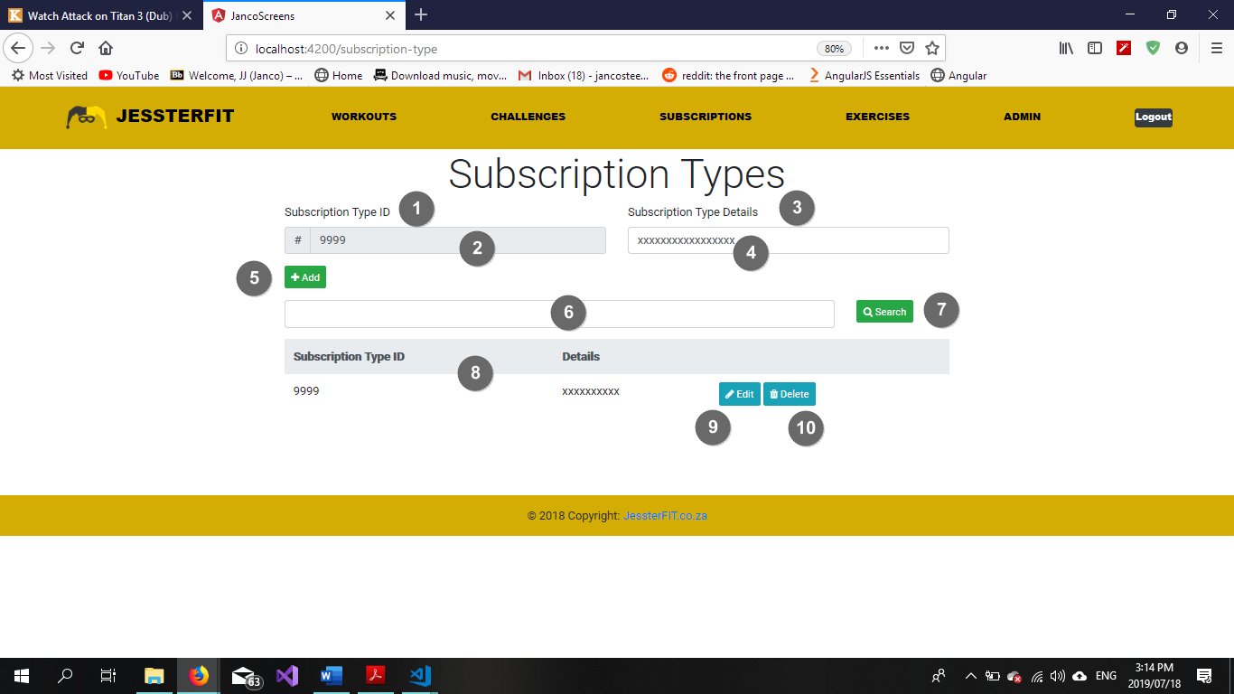

Figure Add Subscription Detail

|  |  |  |
| --- | --- | --- |
| **Screen Name: Subscription Types** | | |
| Item Num: | Item Name: | Item Description: |
| 1 | Subscription Type ID label | Descriptive element |
| 2 | Subscription Type ID textbox | Contains Subscription Type ID |
| 3 | Subscription Type Details label | Descriptive element |
| 4 | Subscription Type Details textbox | Contains Subscription Type Details |
| 5 | Add button | Adds the record to the database |
| 6 | Search textbox | Search Criteria to be entered here |
| 7 | Search button | Clicking this button initiates the search function |
| 8 | Subscription Type Table | Displays all existing Subscription Types |
| 9 | Edit button | Initiates the maintain Subscription Type function |
| 10 | Delete button | Delete a record from the database |

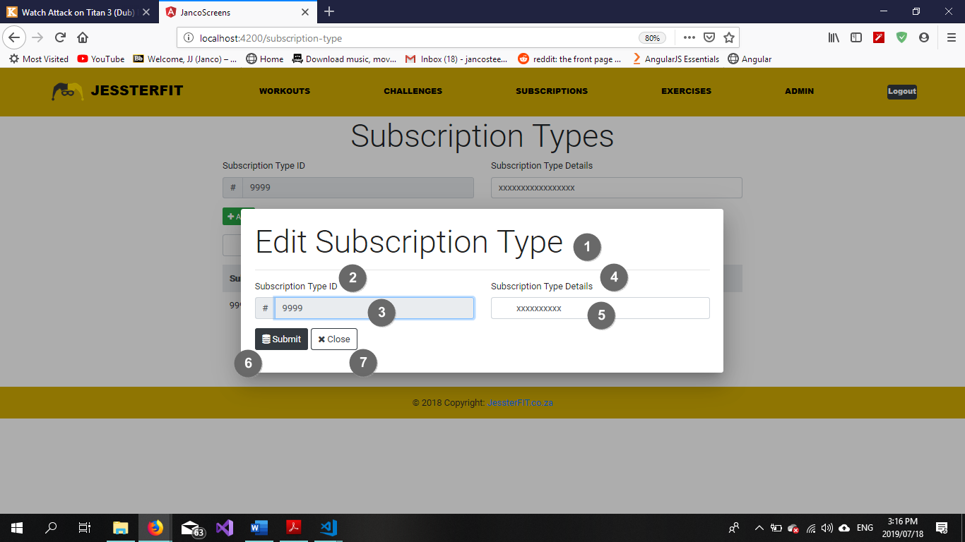

Figure Maintain Subscription Detail

|  |  |  |
| --- | --- | --- |
| **Popup Name: Maintain Subscription Type** | | |
| Item Num: | Item Name: | Item Description: |
| 1 | Edit Subscription Type label | Descriptive element |
| 2 | Subscription Type ID label | Descriptive element |
| 3 | Subscription Type ID textbox | Contains Subscription Type ID |
| 4 | Subscription Type Details label | Descriptive element |
| 5 | Subscription Type Details textbox | Contains Subscription Type Details |
| 6 | Submit button | Update database with maintained details |
| 7 | Close button | Close pop-up and reverts any unsaved changes |

5.1.4 Add New Subscription (Success)

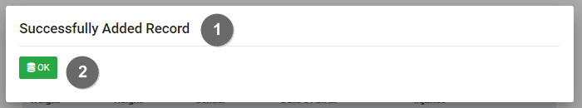

Figure Success Message

|  |  |  |
| --- | --- | --- |
| **Popup Name: Blank Field(s) Error** | | |
| Item Num: | Item Name: | Item Description: |
| 1 | Information label | Displays information regarding current events |
| 2 | Back button | Returns user to a previous state |

5.1.5 Add New Subscription Detail (Blank Fields)

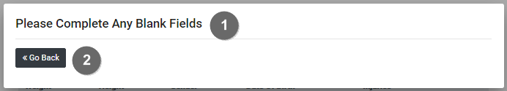

Figure Blank Field Error

|  |  |  |
| --- | --- | --- |
| **Popup Name: Blank Field(s) Error** | | |
| Item Num: | Item Name: | Item Description: |
| 1 | Information label | Displays information regarding current events |
| 2 | Back button | Returns user to a previous state |

5.1.6 Add New Subscription Detail (Invalid Data)

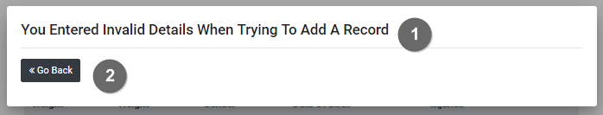

Figure Invalid Data Error

|  |  |  |
| --- | --- | --- |
| **Popup Name: Invalid Data Error** | | |
| Item Num: | Item Name: | Item Description: |
| 1 | Information label | Displays information regarding current events |
| 2 | Back button | Returns user to a previous state |

5.1.7 Search Subscription Detail (No Records Found)

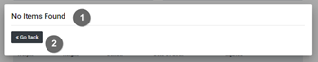

Figure No Records Found Error

|  |  |  |
| --- | --- | --- |
| **Popup Name: No Records Found** | | |
| Item Num: | Item Name: | Item Description: |
| 1 | Information label | Displays information regarding current events |
| 2 | Back button | Navigates the user to a previous state |

5.1.8 Maintain Subscription Detail (Delete Confirmation)

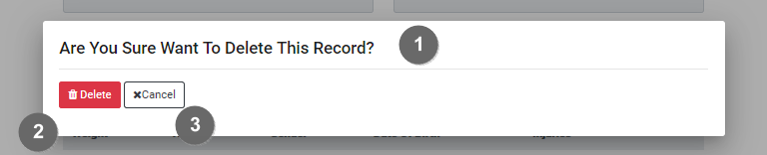

Figure Delete Confirmation

|  |  |  |
| --- | --- | --- |
| **Popup Name: Confirm Delete** | | |
| Item Num: | Item Name: | Item Description: |
| 1 | Information label | Displays information regarding current events |
| 2 | Delete button | Confirms deletion of a record |
| 3 | Cancel button | Cancel the current action |

* 5.1.10 Use Case 1.4 – Add New Challenge
* 5.1.11 Use Case 1.5 – Maintain Challenge
* 5.1.12 Use Case 1.6 – Search Challenge

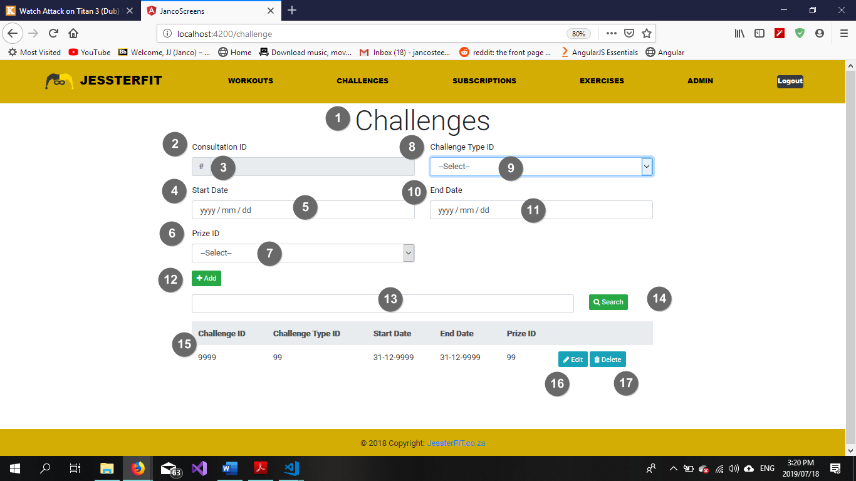

Figure Add Challenge

|  |  |  |
| --- | --- | --- |
| **Screen Name: Maintain Challenge** | | |
| Item Num: | Item Name: | Item Description: |
| 1 | Challenges heading | Descriptive element |
| 2 | Challenge ID label | Descriptive element |
| 3 | Challenge ID textbox | Contains Challenge ID |
| 4 | Start Date label | Descriptive element |
| 5 | Start Date input box (type=date) | Contains Challenge Start Date in date format |
| 6 | Prize ID label | Descriptive element |
| 7 | Prize ID dropdown | Dropdown list which holds all the available prizes for a challenge |
| 8 | Challenge Type ID label | Descriptive element |
| 9 | Challenge Type ID dropdown | Dropdown list which holds all the available challenge types |
| 10 | End Date label | Descriptive element |
| 11 | End Date input box (type=date) | Contains Challenge End Date in date format |
| 12 | Add button | Adds the entered details to the database as a new record |
| 13 | Search textbox | A textbox which holds the search criteria for a challenge |
| 14 | Search button | Initiates the search function |
| 15 | Challenge table | Contains all existing challenges |
| 16 | Edit button | Initiates the maintain challenge function |
| 17 | Delete button | Removes the selected record from the database |

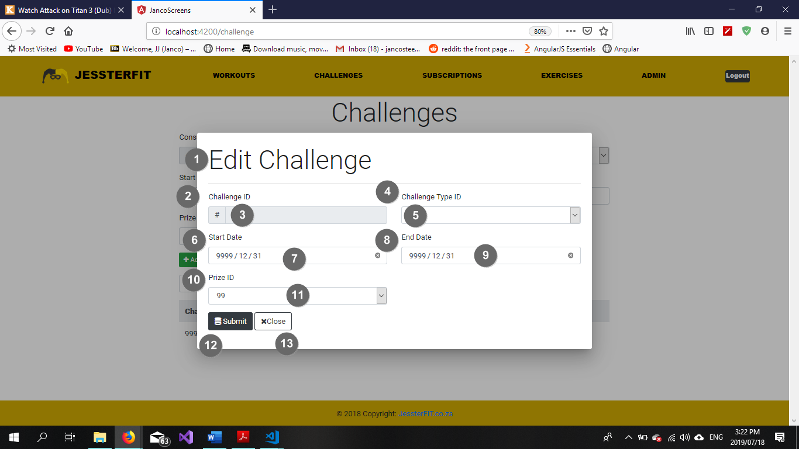

Figure Maintain Challenge

|  |  |  |
| --- | --- | --- |
| **Popup Name: Maintain Challenge** | | |
| Item Num: | Item Name: | Item Description: |
| 1 | Edit Challenges heading | Descriptive element |
| 2 | Challenge ID label | Descriptive element |
| 3 | Challenge ID textbox | Contains Challenge ID |
| 4 | Challenge Type ID label | Descriptive element |
| 5 | Challenge Type ID dropdown | Dropdown list which holds all the available challenge types |
| 6 | Start Date label | Descriptive element |
| 7 | Start Date input box (type=date) | Contains Challenge Start Date in date format |
| 8 | End Date label | Descriptive element |
| 9 | End Date input box (type=date) | Contains Challenge End Date in date format |
| 10 | Prize ID label | Descriptive element |
| 11 | Prize ID dropdown | Dropdown list which holds all the available prizes for a challenge |
| 12 | Submit button | Updates the entered details to the database |
| 13 | Close textbox | Cancels the action and closes the pop-up |

5.1.13 Add New Subscription (Success)



Figure 10 Success Message

|  |  |  |
| --- | --- | --- |
| **Popup Name: Blank Field(s) Error** | | |
| Item Num: | Item Name: | Item Description: |
| 1 | Information label | Displays information regarding current events |
| 2 | Back button | Returns user to a previous state |

5.1.14 Add New Challenge (Blank Fields)



Figure 11 Blank Field Error

|  |  |  |
| --- | --- | --- |
| **Popup Name: Blank Field(s) Error** | | |
| Item Num: | Item Name: | Item Description: |
| 1 | Information label | Displays information regarding current events |
| 2 | Back button | Returns user to a previous state |

5.1.15 Add New Challenge (Invalid Data)



Figure 12 Invalid Data Error

|  |  |  |
| --- | --- | --- |
| **Popup Name: Invalid Data Error** | | |
| Item Num: | Item Name: | Item Description: |
| 1 | Information label | Displays information regarding current events |
| 2 | Back button | Returns user to a previous state |

5.1.14 Search Challenge (No Records Found)



Figure 13 No Records Found Error

|  |  |  |
| --- | --- | --- |
| **Popup Name: No Records Found** | | |
| Item Num: | Item Name: | Item Description: |
| 1 | Information label | Displays information regarding current events |
| 2 | Back button | Navigates the user to a previous state |

5.1.15 Maintain Challenge (Delete Confirmation)



Figure 14 Delete Confirmation

|  |  |  |
| --- | --- | --- |
| **Popup Name: Confirm Delete** | | |
| Item Num: | Item Name: | Item Description: |
| 1 | Information label | Displays information regarding current events |
| 2 | Delete button | Confirms deletion of a record |
| 3 | Cancel button | Cancel the current action |

* 5.1.16 Use Case 1.7 – Add New Booking Slots
* 5.1.17 Use Case 1.8 – Maintain Booking Slots
* 5.1.18 Use Case 1.9 – Search Booking Slots

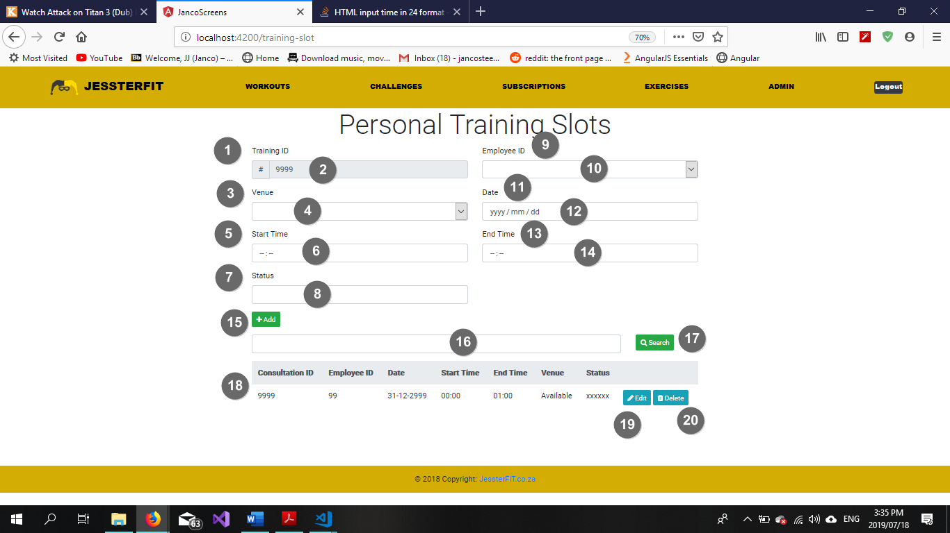

Figure 15 Add Booking Slot

|  |  |  |
| --- | --- | --- |
| **Screen Name: Booking Slot Screen** | | |
| Item Num: | Item Name: | Item Description: |
| 1 | Training ID label | Descriptive element |
| 2 | Training ID textbox | Contains Training ID |
| 3 | Venue label | Descriptive element |
| 4 | Venue textbox | Contains Venue |
| 5 | Start Time label | Descriptive element |
| 6 | Start Time input box (type=time) | Personal training Start Time in time format |
| 7 | Status label | Descriptive element |
| 8 | Status textbox | Contains Status of the personal training booking slot |
| 9 | Employee ID label | Descriptive element |
| 10 | Employee ID dropdown list | Contains a list of Employee IDs available to lead a booking slot |
| 11 | Date label | Descriptive element |
| 12 | Date input box (type=date) | Contains Training slot Date in date format |
| 13 | End Time label | Descriptive element |
| 14 | End Time input box (type=time) | Personal training End Time in time format |
| 15 | Add button | Adds the entered details to the database as a new record |
| 16 | Search textbox | A textbox which holds the search criteria for a challenge |
| 17 | Search button | Initiates the search function |
| 18 | Personal Training Booking table | Contains all existing booking slots |
| 19 | Edit button | Initiates the maintain booking slot function |
| 20 | Delete button | Removes the selected record from the database |

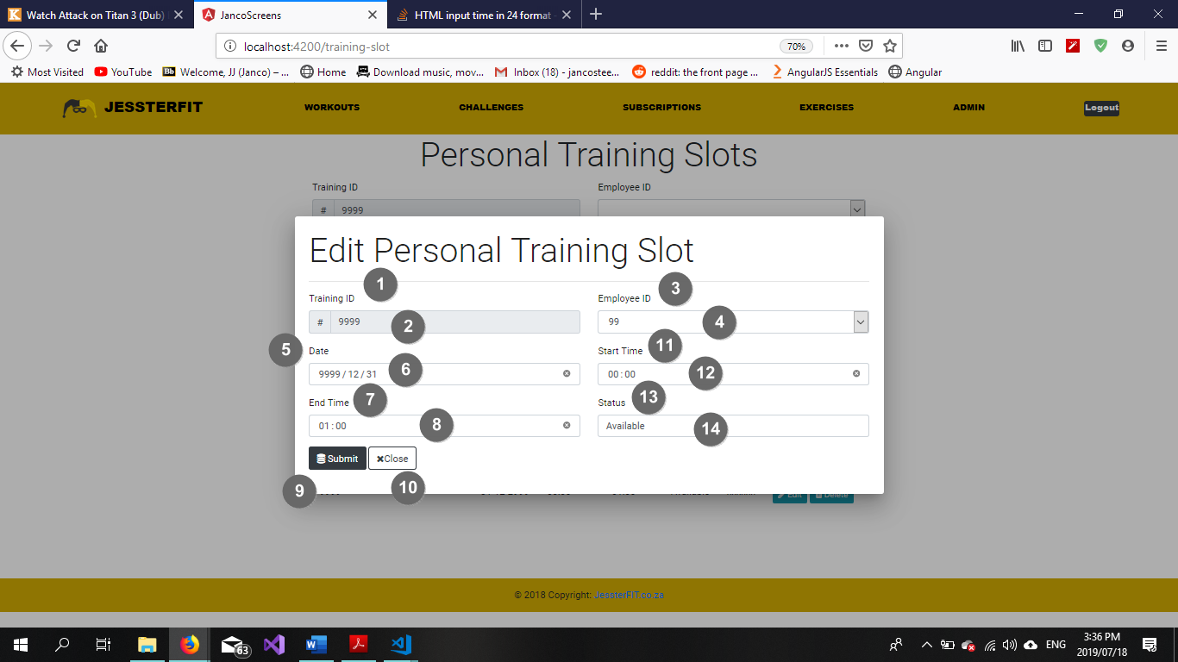

Figure 16 Maintain Booking Slots

|  |  |  |
| --- | --- | --- |
| **Popup Name: Maintain Training Booking Slot** | | |
| Item Num: | Item Name: | Item Description: |
| 1 | Training ID label | Descriptive element |
| 2 | Training ID textbox | Contains Training ID |
| 3 | Employee ID label | Descriptive element |
| 4 | Employee ID textbox | Contains Employee ID |
| 5 | Date label | Descriptive element |
| 6 | Date input box (type=date) | Contains Training Date in date format |
| 7 | End Time Label | Descriptive element |
| 8 | End Time input box (type=time) | Contains End Time in time format |
| 9 | Submit button | Updates the entered details to the database |
| 10 | Close textbox | Cancels the action and closes the pop-up |
| 11 | Start Time Label | Descriptive element |
| 12 | Start Time input box (type=time) | Contains Start Time in time format |
| 13 | Status label | Descriptive element |
| 14 | Status input box | Contains Status of booking |

5.1.20 Add New Booking Slot (Success)



Figure 17 Success Message

|  |  |  |
| --- | --- | --- |
| **Popup Name: Blank Field(s) Error** | | |
| Item Num: | Item Name: | Item Description: |
| 1 | Information label | Displays information regarding current events |
| 2 | Back button | Returns user to a previous state |

5.1.21 Add New Booking Slot (Blank Fields)



Figure 18 Blank Field Error

|  |  |  |
| --- | --- | --- |
| **Popup Name: Blank Field(s) Error** | | |
| Item Num: | Item Name: | Item Description: |
| 1 | Information label | Displays information regarding current events |
| 2 | Back button | Returns user to a previous state |

5.1.22 Add New Booking Slot (Invalid Data)



Figure 19 Invalid Data Error

|  |  |  |
| --- | --- | --- |
| **Popup Name: Invalid Data Error** | | |
| Item Num: | Item Name: | Item Description: |
| 1 | Information label | Displays information regarding current events |
| 2 | Back button | Returns user to a previous state |

5.1.23 Search Booking Slot (No Records Found)



Figure 20 No Records Found Error

|  |  |  |
| --- | --- | --- |
| **Popup Name: No Records Found** | | |
| Item Num: | Item Name: | Item Description: |
| 1 | Information label | Displays information regarding current events |
| 2 | Back button | Navigates the user to a previous state |

5.1.15 Maintain Booking Slot (Delete Confirmation)



Figure 21 Delete Confirmation

|  |  |  |
| --- | --- | --- |
| **Popup Name: Confirm Delete** | | |
| Item Num: | Item Name: | Item Description: |
| 1 | Information label | Displays information regarding current events |
| 2 | Delete button | Confirms deletion of a record |
| 3 | Cancel button | Cancel the current action |

5.1.24 Use Case 1.10 – Maintain Company

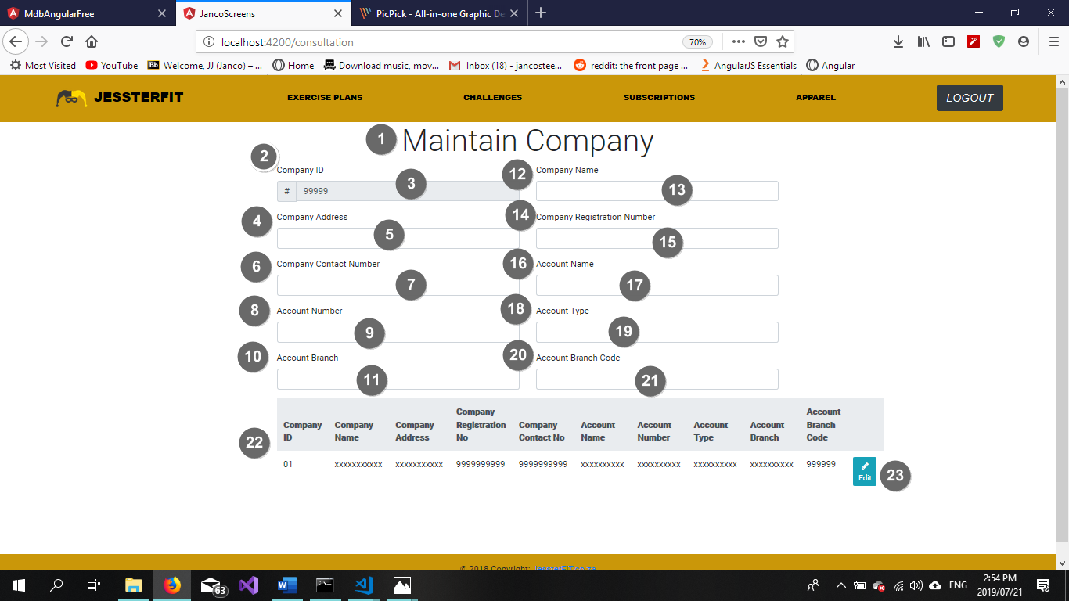

|  |  |  |
| --- | --- | --- |
| **Screen Name: Booking Slot Screen** | | |
| Item Num: | Item Name: | Item Description: |
| 1 | Maintain Company header | Descriptive element |
| 2 | Company ID label | Descriptive element |
| 3 | Company ID textbox | Contains Company ID |
| 4 | Company Address label | Descriptive element |
| 5 | Company Address textbox | Contains Company Address |
| 6 | Company Contact Number label | Descriptive element |
| 7 | Company Contact Number textbox | Contains Company Contact Number |
| 8 | Account Number label | Descriptive element |
| 9 | Account Number input box | Contains Account Number |
| 10 | Account Branch label | Descriptive element |
| 11 | Account Branch textbox | Contains Account Branch |
| 12 | Company Name label | Descriptive element |
| 13 | Company Name textbox | Contains Company Name |
| 14 | Company Registration Number label | Descriptive element |
| 15 | Company Registration Number input box | Contains Company Registration Number |
| 16 | Account Name label | Descriptive element |
| 17 | Account Name input box | Contains Account Name |
| 18 | Account Type label | Descriptive element |
| 19 | Account Type textbox | Contains Account Type |
| 20 | Account Branch Code label | Descriptive element |
| 21 | Account Branch Code textbox | Contains Account Branch Code |
| 22 | Company table | Contains all data regarding the Company |
| 23 | Edit button | Allows the user to edit a record |

5.1.25 Maintain Company (Blank Fields)



Figure 22 Blank Field Error

|  |  |  |
| --- | --- | --- |
| **Popup Name: Blank Field(s) Error** | | |
| Item Num: | Item Name: | Item Description: |
| 1 | Information label | Displays information regarding current events |
| 2 | Back button | Returns user to a previous state |

5.1.26 Maintain Company (Invalid Data)



Figure 23 Invalid Data Error

|  |  |  |
| --- | --- | --- |
| **Popup Name: Invalid Data Error** | | |
| Item Num: | Item Name: | Item Description: |
| 1 | Information label | Displays information regarding current events |
| 2 | Back button | Returns user to a previous state |

5.1.27 Use Case 1.13 – Confirm Payment

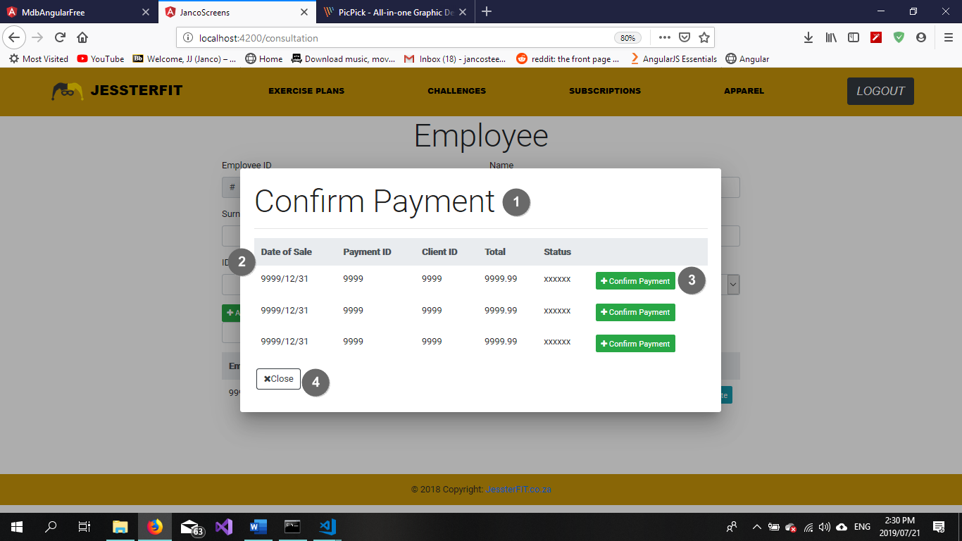

|  |  |  |
| --- | --- | --- |
| **Popup Name: Maintain Training Booking Slot** | | |
| Item Num: | Item Name: | Item Description: |
| 1 | Confirm Payment heading | Descriptive element |
| 2 | Outstanding Payments table | Contains all Outstanding Payment |
| 3 | Confirm Payment button | Allows the owner/employee to confirm that a payment has been made |
| 4 | Close button | Closes the pop up and returns the user to their previous page |

5.1.28 Use Case 1.14 – Search Sale

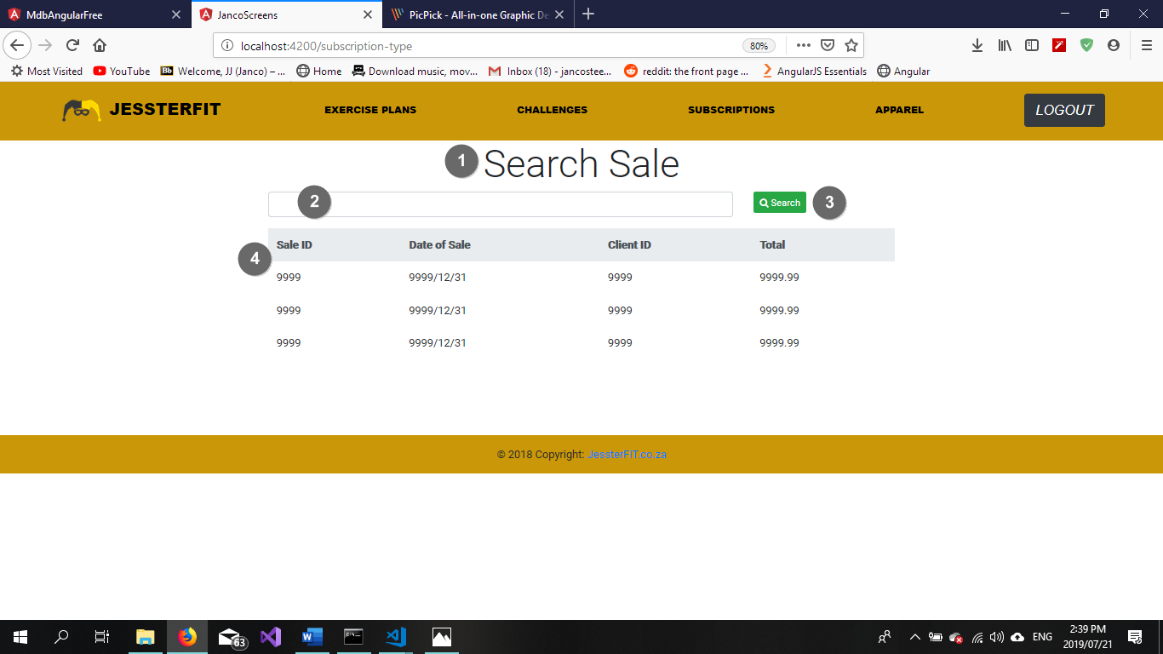

|  |  |  |
| --- | --- | --- |
| **Popup Name: Maintain Training Booking Slot** | | |
| Item Num: | Item Name: | Item Description: |
| 1 | Search Sale heading | Descriptive element |
| 2 | Search textbox | A textbox which holds the search criteria for a challenge |
| 3 | Search button | Initiates the search function |
| 4 | Sale table | Contains all existing Sales |

5.1.29 Use Case 1.15 Conduct Consultation

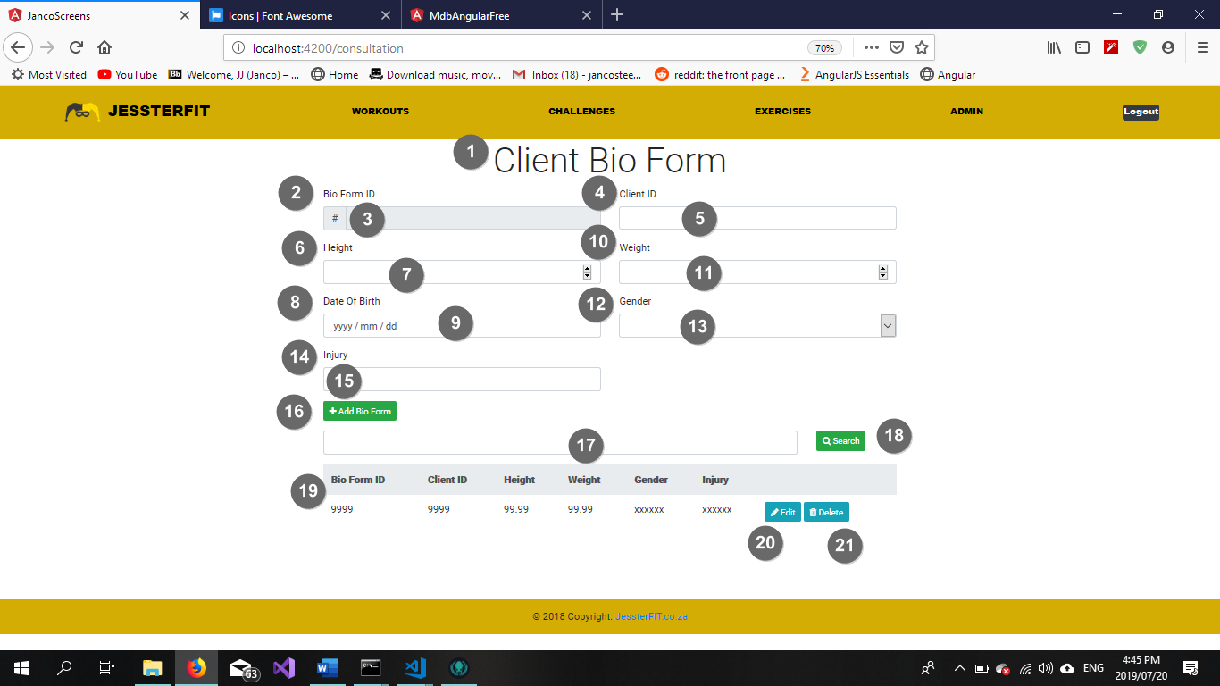

Figure 24 Conduct Consultation

|  |  |  |
| --- | --- | --- |
| **Screen Name: Client Bio Form Screen** | | |
| Item Num: | Item Name: | Item Description: |
| 1 | Client Bio Form heading | Descriptive element |
| 2 | Bio Form ID label | Descriptive element |
| 3 | Bio Form ID input box | Contains Bio Form ID |
| 4 | Client ID label | Descriptive element |
| 5 | Client ID input box | Contains Client ID |
| 6 | Height label | Descriptive element |
| 7 | Height input box | Contains Client Height |
| 8 | Date of Birth label | Descriptive element |
| 9 | Date of Birth input box (type=date) | Contains Client Date of birth |
| 10 | Weight label | Descriptive element |
| 11 | Weight input box | Contains Client Weight |
| 12 | Gender label | Descriptive element |
| 13 | Gender dropdown list | Contains Gender details |
| 14 | Injury label | Descriptive element |
| 15 | Injury input box | Contains Injury details |
| 16 | Add button | Adds the entered details to the database as a new record |
| 17 | Search textbox | A textbox which holds the search criteria for a challenge |
| 18 | Search button | Initiates the search function |
| 19 | Client Bio Form table | Contains all existing bio form information |
| 20 | Edit button | Initiates the maintain bio form function |
| 21 | Delete button | Removes the selected record from the database |

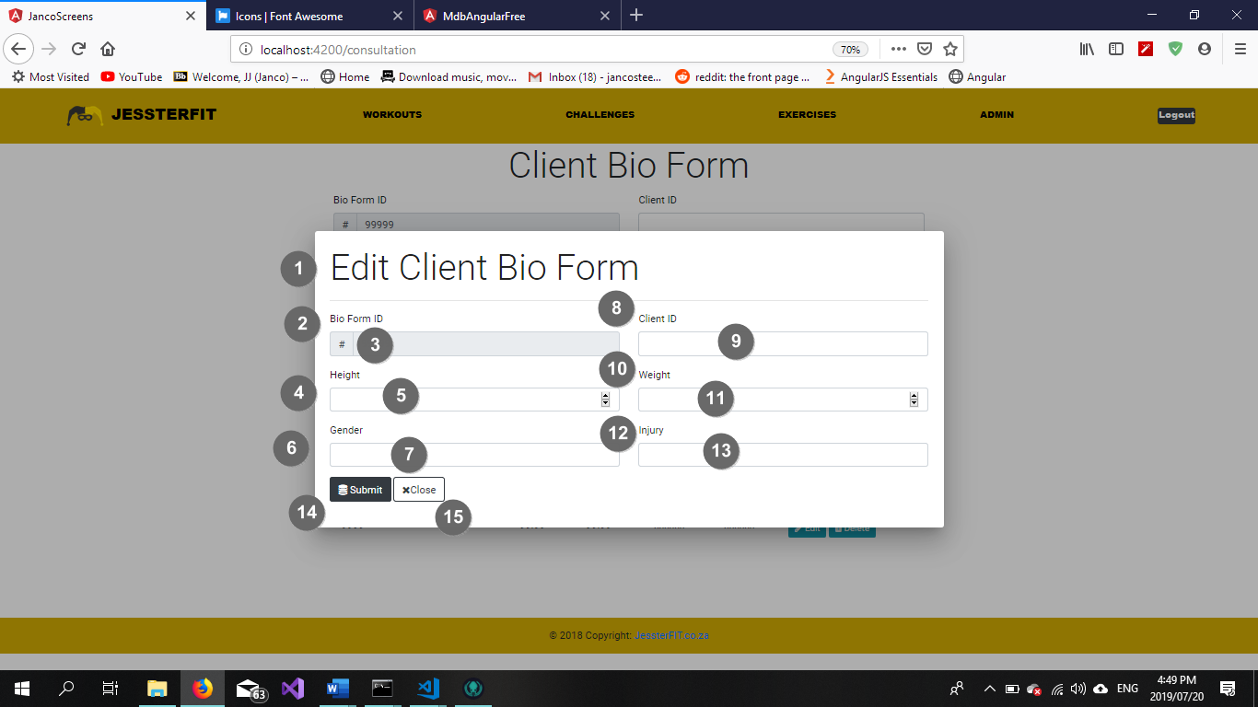

Figure 25 Maintain Consultation

|  |  |  |
| --- | --- | --- |
| **Popup Name: Edit Bio Form** | | |
| Item Num: | Item Name: | Item Description: |
| 1 | Edit Client Bio Form heading | Descriptive element |
| 2 | Bio Form ID label | Descriptive element |
| 3 | Bio Form ID textbox | Contains Bio Form ID |
| 4 | Height label | Descriptive element |
| 5 | Height textbox | Contains Height |
| 6 | Gender label | Descriptive element |
| 7 | Gender textbox | Contains Gender |
| 8 | Client ID Label | Descriptive element |
| 9 | Client ID input box | Contains Client ID |
| 10 | Weight Label | Descriptive element |
| 11 | Weight input box | Contains Weight |
| 12 | Injury label | Descriptive element |
| 13 | Injury input box | Contains Injury of client |
| 14 | Submit button | Updates the entered details to the database |
| 15 | Close textbox | Cancels the action and closes the pop-up |

5.1.30 Add Bio Form (Success)



Figure 26 Success Message

|  |  |  |
| --- | --- | --- |
| **Popup Name: Blank Field(s) Error** | | |
| Item Num: | Item Name: | Item Description: |
| 1 | Information label | Displays information regarding current events |
| 2 | Back button | Returns user to a previous state |

5.1.31 Add Bio Form (Blank Fields)



Figure 27 Blank Field Error

|  |  |  |
| --- | --- | --- |
| **Popup Name: Blank Field(s) Error** | | |
| Item Num: | Item Name: | Item Description: |
| 1 | Information label | Displays information regarding current events |
| 2 | Back button | Returns user to a previous state |

5.1.32 Add Bio Form (Invalid Data)



Figure 28 Invalid Data Error

|  |  |  |
| --- | --- | --- |
| **Popup Name: Invalid Data Error** | | |
| Item Num: | Item Name: | Item Description: |
| 1 | Information label | Displays information regarding current events |
| 2 | Back button | Returns user to a previous state |

5.1.33 Search Booking Slot (No Records Found)



Figure 29 No Records Found Error

|  |  |  |
| --- | --- | --- |
| **Popup Name: No Records Found** | | |
| Item Num: | Item Name: | Item Description: |
| 1 | Information label | Displays information regarding current events |
| 2 | Back button | Navigates the user to a previous state |

5.1.34 Maintain Booking Slot (Delete Confirmation)



Figure 30 Delete Confirmation

|  |  |  |
| --- | --- | --- |
| **Popup Name: Confirm Delete** | | |
| Item Num: | Item Name: | Item Description: |
| 1 | Information label | Displays information regarding current events |
| 2 | Delete button | Confirms deletion of a record |
| 3 | Cancel button | Cancel the current action |

## 5.2 Subsystem 2: Employee Subsystem

* 5.2.1 Use Case 2.1 – Add New Employee
* 5.2.2 Use Case 2.2 – Maintain Employee
* 5.2.3 Use Case 2.3 – Search Employee

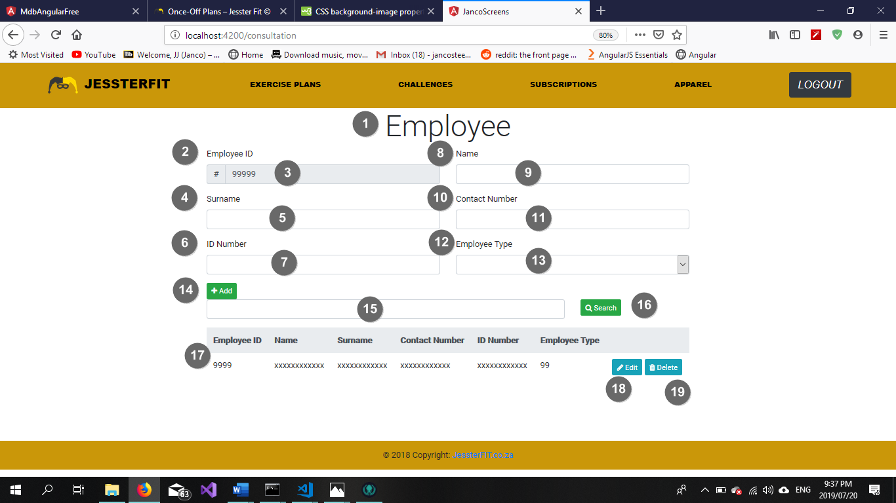

Figure 31 Add New Employee

|  |  |  |
| --- | --- | --- |
| **Screen Name: Employee Screen** | | |
| Item Num: | Item Name: | Item Description: |
| 1 | Employee heading | Descriptive element |
| 2 | Employee ID label | Descriptive element |
| 3 | Employee ID input box | Contains Employee ID |
| 4 | Surname label | Descriptive element |
| 5 | Surname input box | Contains employee Surname |
| 6 | ID Number label | Descriptive element |
| 7 | ID Number input box | Contains employee ID Number |
| 8 | Name label | Descriptive element |
| 9 | Name input box | Contains employee Name |
| 10 | Contact Number label | Descriptive element |
| 11 | Contact Number input box | Contains Contact Number |
| 12 | Employee Type label | Descriptive element |
| 13 | Employee Type dropdown list | Contains Employee details |
| 14 | Add button | Adds the entered details to the database as a new record |
| 15 | Search textbox | A textbox which holds the search criteria for an employee |
| 16 | Search button | Initiates the search function |
| 17 | Employee table | Contains all existing employee information |
| 18 | Edit button | Initiates the maintain employee function |
| 19 | Delete button | Removes the selected record from the database |

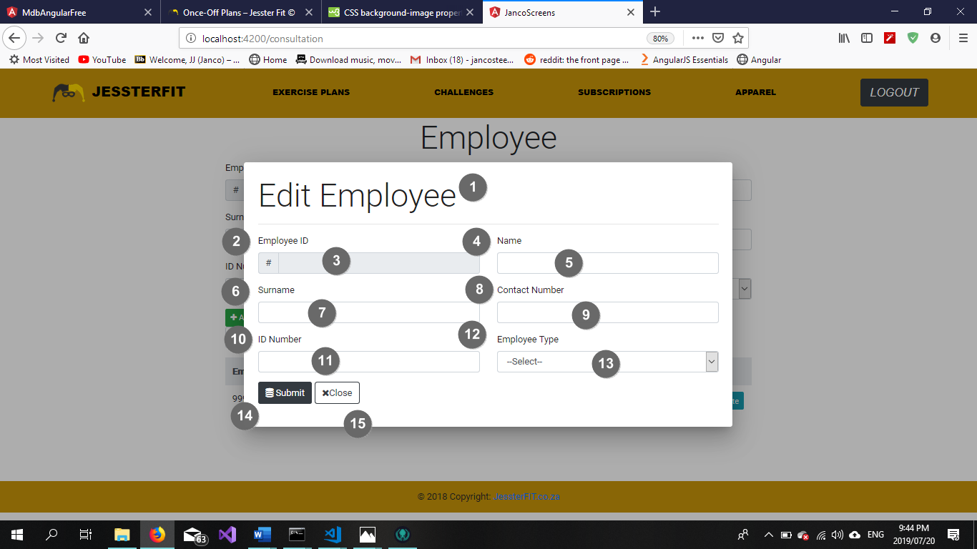

Figure 32 Maintain Employee

|  |  |  |
| --- | --- | --- |
| **Popup Name: Edit Employee** | | |
| Item Num: | Item Name: | Item Description: |
| 1 | Edit Employee heading | Descriptive element |
| 2 | Employee ID label | Descriptive element |
| 3 | Employee ID textbox | Contains Employee ID |
| 4 | Name label | Descriptive element |
| 5 | Name textbox | Contains employee Name |
| 6 | Surname label | Descriptive element |
| 7 | Surname textbox | Contains employee Surname |
| 8 | Contact Number Label | Descriptive element |
| 9 | Contact Number input box | Contains employee Contact Number |
| 10 | ID Number Label | Descriptive element |
| 11 | ID Number input box | Contains employee ID Number |
| 12 | Employee Type label | Descriptive element |
| 13 | Employee Type drop down list | Contains list of Employee Types |
| 14 | Submit button | Updates the entered details to the database |
| 15 | Close textbox | Cancels the action and closes the pop-up |

5.2.4 Add New Employee (Success)



Figure 33 Success Message

|  |  |  |
| --- | --- | --- |
| **Popup Name: Blank Field(s) Error** | | |
| Item Num: | Item Name: | Item Description: |
| 1 | Information label | Displays information regarding current events |
| 2 | Back button | Returns user to a previous state |

5.2.5 Add New Employee(Blank Fields)



Figure 34 Blank Field Error

|  |  |  |
| --- | --- | --- |
| **Popup Name: Blank Field(s) Error** | | |
| Item Num: | Item Name: | Item Description: |
| 1 | Information label | Displays information regarding current events |
| 2 | Back button | Returns user to a previous state |

5.2.6 Add New Employee (Invalid Data)



Figure 35 Invalid Data Error

|  |  |  |
| --- | --- | --- |
| **Popup Name: Invalid Data Error** | | |
| Item Num: | Item Name: | Item Description: |
| 1 | Information label | Displays information regarding current events |
| 2 | Back button | Returns user to a previous state |

5.2.7 Search Employee (No Records Found)



Figure 36 No Records Found Error

|  |  |  |
| --- | --- | --- |
| **Popup Name: No Records Found** | | |
| Item Num: | Item Name: | Item Description: |
| 1 | Information label | Displays information regarding current events |
| 2 | Back button | Navigates the user to a previous state |

5.2.8 Maintain Employee (Delete Confirmation)



Figure 37 Delete Confirmation

|  |  |  |
| --- | --- | --- |
| **Popup Name: Confirm Delete** | | |
| Item Num: | Item Name: | Item Description: |
| 1 | Information label | Displays information regarding current events |
| 2 | Delete button | Confirms deletion of a record |
| 3 | Cancel button | Cancel the current action |

* 5.2.9 Use Case 2.4 Add New Employee Type
* 5.2.10 Use Case 2.5 Maintain Employee Type
* 5.2.11 Use Case 2.6 Search Employee Type

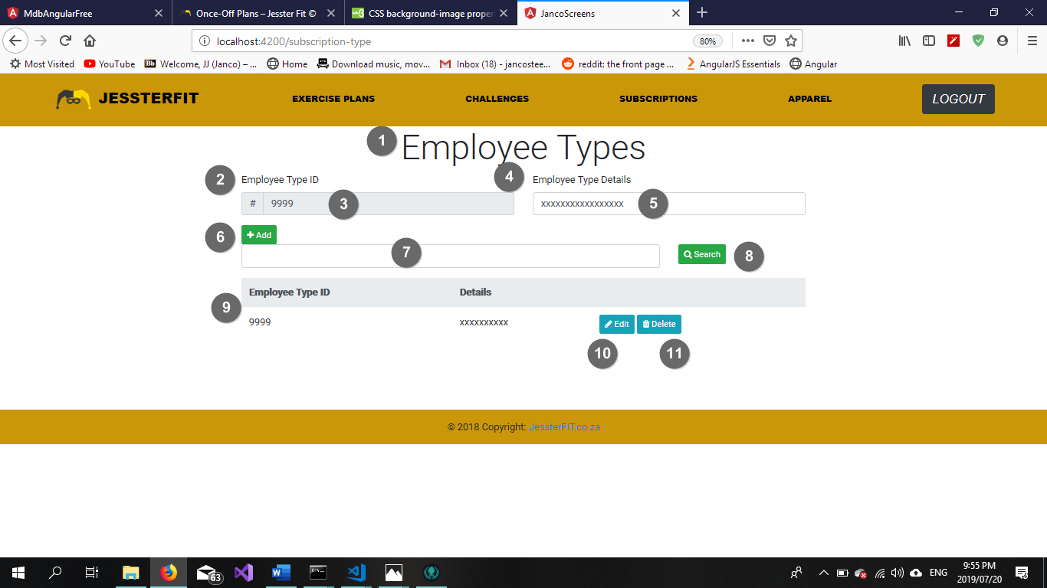

Figure 38 Add New Employee

|  |  |  |
| --- | --- | --- |
| **Screen Name: Employee Types Screen** | | |
| Item Num: | Item Name: | Item Description: |
| 1 | Employee Type heading | Descriptive element |
| 2 | Employee Type ID label | Descriptive element |
| 3 | Employee Type ID input box | Contains Employee Type ID |
| 4 | Employee Type Description label | Descriptive element |
| 5 | Employee Type Description input box | Contains Employee Type Description |
| 6 | Add button | Adds the entered details to the database as a new record |
| 7 | Search textbox | A textbox which holds the search criteria for an employee type |
| 8 | Search button | Initiates the search function |
| 9 | Employee Type table | Contains all existing employee type information |
| 10 | Edit button | Initiates the maintain employee type function |
| 11 | Delete button | Removes the selected record from the database |

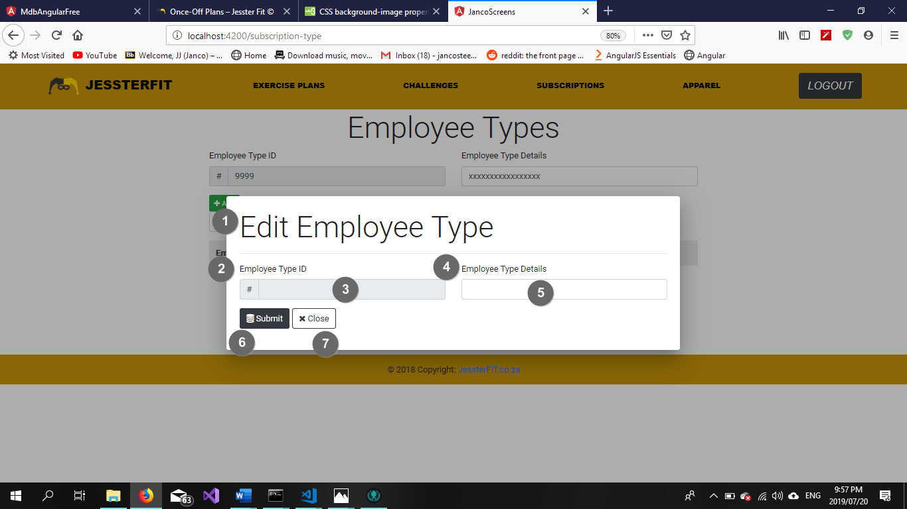

Figure 39 Maintain Employee

|  |  |  |
| --- | --- | --- |
| **Popup Name: Edit Employee Type** | | |
| Item Num: | Item Name: | Item Description: |
| 1 | Edit Employee Type heading | Descriptive element |
| 2 | Employee Type ID label | Descriptive element |
| 3 | Employee Type ID textbox | Contains Employee Type ID |
| 4 | Employee Type Details label | Descriptive element |
| 5 | Employee Type Details textbox | Contains Employee Type Details |
| 6 | Submit button | Updates the entered details to the database |
| 7 | Close textbox | Cancels the action and closes the pop-up |

5.2.12 Add New Employee Type (Success)



Figure 40 Success Message

|  |  |  |
| --- | --- | --- |
| **Popup Name: Blank Field(s) Error** | | |
| Item Num: | Item Name: | Item Description: |
| 1 | Information label | Displays information regarding current events |
| 2 | Back button | Returns user to a previous state |

5.2.13 Add New Employee (Blank Fields)



Figure 41 Blank Field Error

|  |  |  |
| --- | --- | --- |
| **Popup Name: Blank Field(s) Error** | | |
| Item Num: | Item Name: | Item Description: |
| 1 | Information label | Displays information regarding current events |
| 2 | Back button | Returns user to a previous state |

5.2.14 Add New Employee (Invalid Data)



Figure 42 Invalid Data Error

|  |  |  |
| --- | --- | --- |
| **Popup Name: Invalid Data Error** | | |
| Item Num: | Item Name: | Item Description: |
| 1 | Information label | Displays information regarding current events |
| 2 | Back button | Returns user to a previous state |

5.2.15 Search Employee (No Records Found)



Figure 43 No Records Found Error

|  |  |  |
| --- | --- | --- |
| **Popup Name: No Records Found** | | |
| Item Num: | Item Name: | Item Description: |
| 1 | Information label | Displays information regarding current events |
| 2 | Back button | Navigates the user to a previous state |

5.2.15 Maintain Employee (Delete Confirmation)



Figure 44 Delete Confirmation

|  |  |  |
| --- | --- | --- |
| **Popup Name: Confirm Delete** | | |
| Item Num: | Item Name: | Item Description: |
| 1 | Information label | Displays information regarding current events |
| 2 | Delete button | Confirms deletion of a record |
| 3 | Cancel button | Cancel the current action |

## 5.3 Subsystem 3: Client Subsystem

5.3.1 Use Case 3.1 – Register New Client

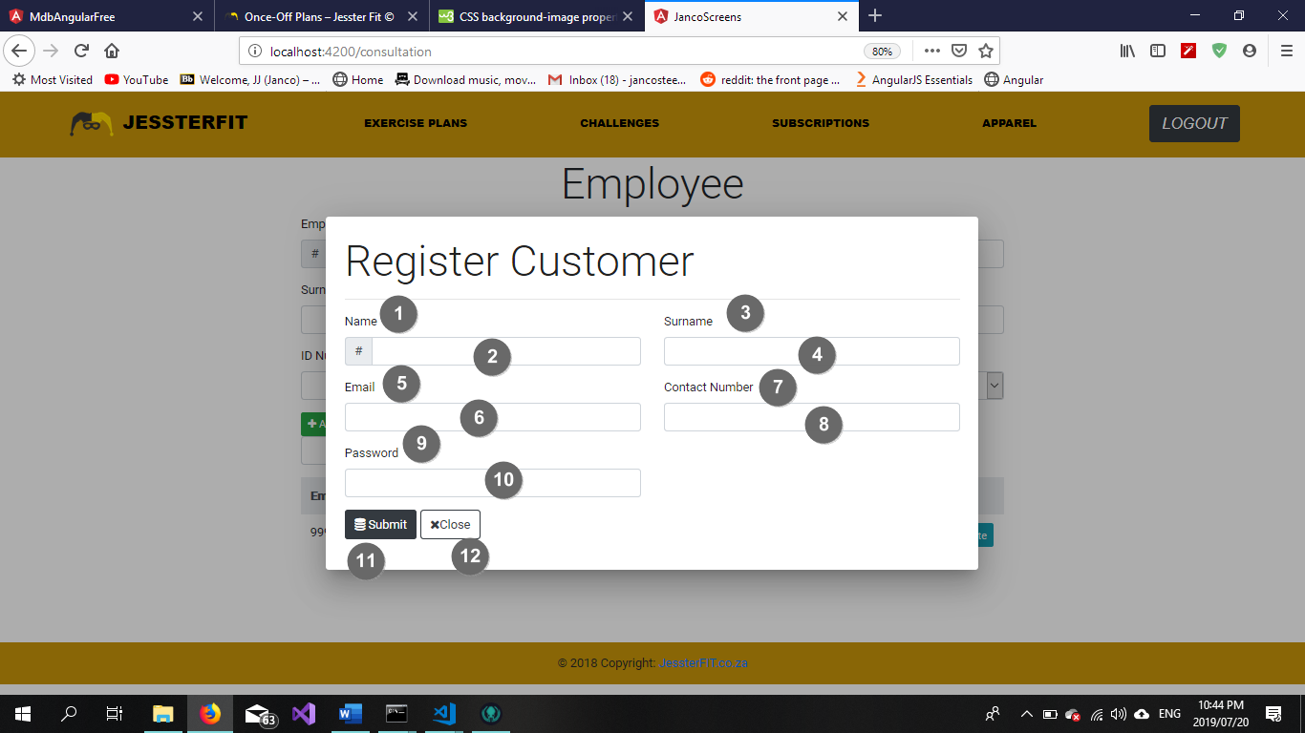

Figure 45 Register Client

|  |  |  |
| --- | --- | --- |
| **Popup Name: Register Customer** | | |
| Item Num: | Item Name: | Item Description: |
| 1 | Name label | Descriptive element |
| 2 | Name textbox | Contains customer Name |
| 3 | Surname label | Descriptive element |
| 4 | Surname textbox | Contains customer Surname |
| 5 | Email label | Descriptive element |
| 6 | Email textbox | Contains customer Email |
| 7 | Contact Number label | Descriptive element |
| 8 | Contact Number input box | Contains customer Contact Number |
| 9 | Password label | Descriptive element |
| 10 | Password input box | Contains customer Password |
| 11 | Submit button | Updates the entered details to the database |
| 12 | Close textbox | Cancels the action and closes the pop-up |

5.3.2 Use Case 3.2 - Maintain Client Profile

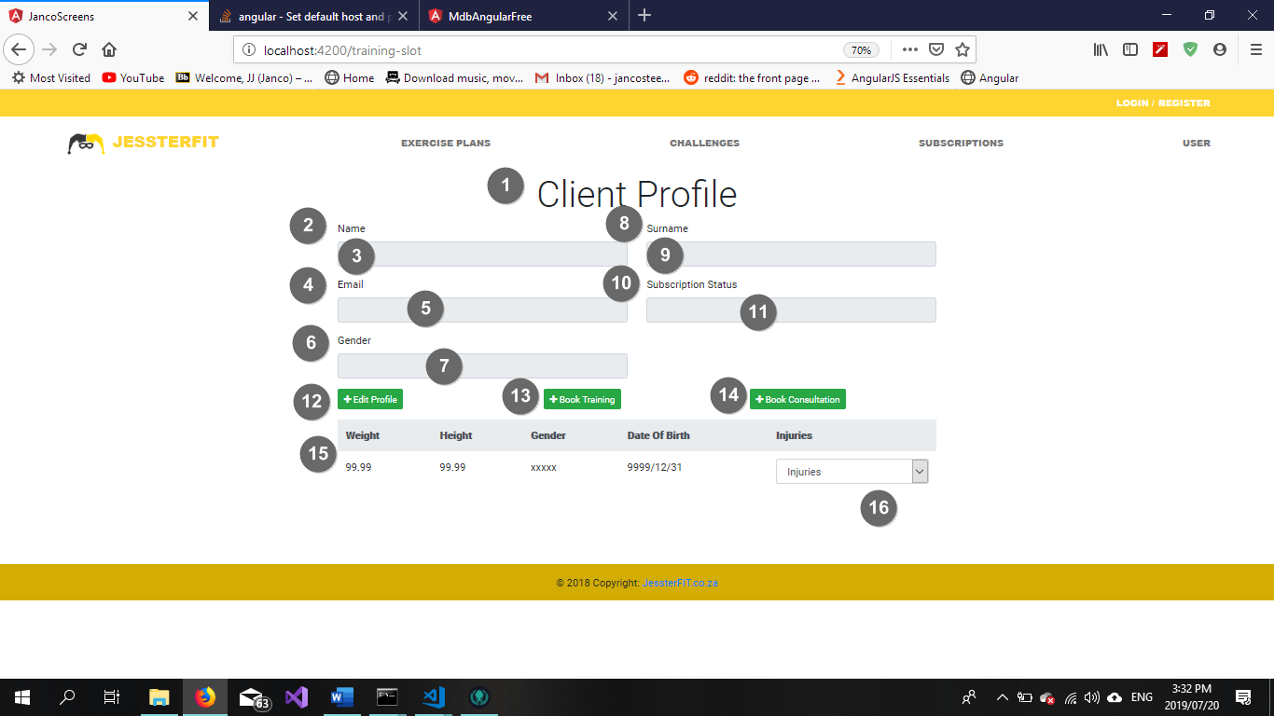

Figure 46 Client Profile

|  |  |  |
| --- | --- | --- |
| **Screen Name: Client Profile** | | |
| Item Num: | Item Name: | Item Description: |
| 1 | Client Profile heading | Descriptive element |
| 2 | Name label | Descriptive element |
| 3 | Name input box | Contains client Name |
| 4 | Email label | Descriptive element |
| 5 | Email input box | Contains client Email |
| 6 | Gender label | Descriptive element |
| 7 | Gender drop down list | Contains customer Gender |
| 8 | Surname label | Descriptive element |
| 9 | Surname input box | Contains customer Surname |
| 10 | Subscription Status label | Descriptive element |
| 11 | Subscription Status input box | Contains client Subscription Status |
| 12 | Edit button | Initiates maintain client |
| 13 | Book Training button | Initiates make personal training booking |
| 14 | Book Consultation button | Initiates make consultation booking |
| 15 | Search textbox | A textbox which holds the search criteria for an employee |
| 16 | Client Profile table | Contains all existing client profile information |

5.3.4 Use Case 3.4 – Sign up For A Subscription

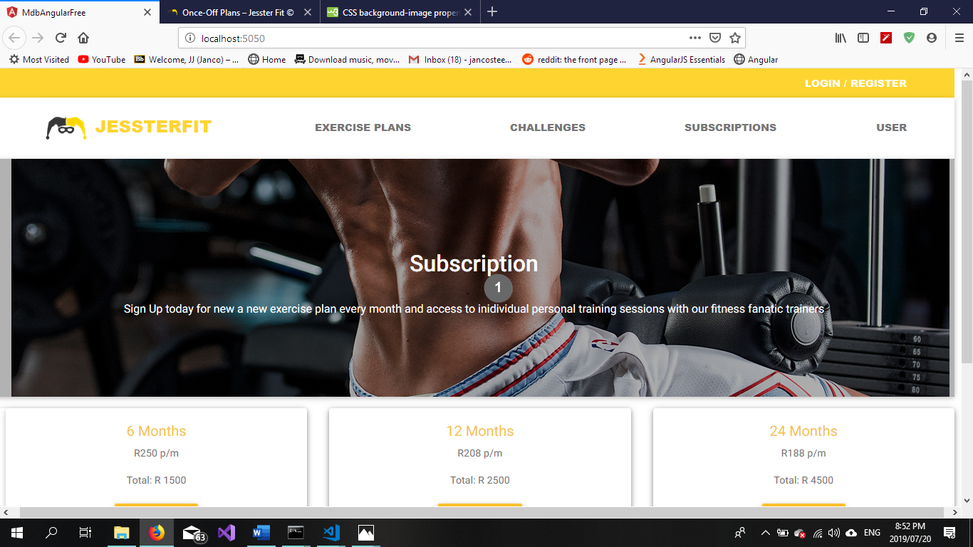

Figure 47 Subscription Sign up Part 1

|  |  |  |
| --- | --- | --- |
| **Screen Name: Sign up for subscription** | | |
| Item Num: | Item Name: | Item Description: |
| 1 | Subscription header and Info | Descriptive element |

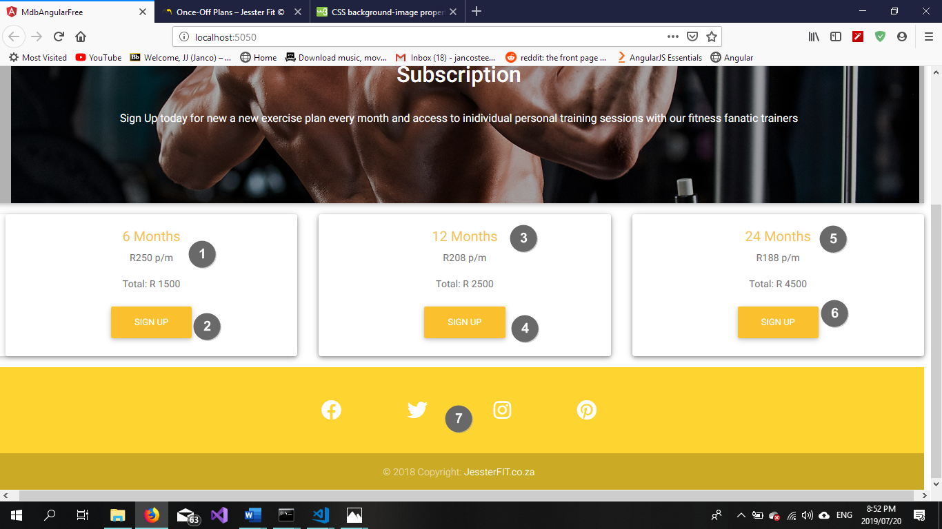

Figure 48 Subscription Sign Up Part 2

|  |  |  |
| --- | --- | --- |
| **Screen Name: Sign up for subscription** | | |
| Item Num: | Item Name: | Item Description: |
| 1 | 6-month subscription label | Descriptive element |
| 2 | Sign Up button | Allows user to sign up for a subscription |
| 3 | 12-month subscription label | Descriptive element |
| 4 | Sign Up button | Allows user to sign up for a subscription |
| 5 | 24-month subscription label | Descriptive element |
| 6 | Sign Up button | Allows user to sign up for a subscription |
| 7 | Assorted social media links | Links the user to the business’ social media accounts |

5.3.5 Use Case 3.5 – Register For A Challenge

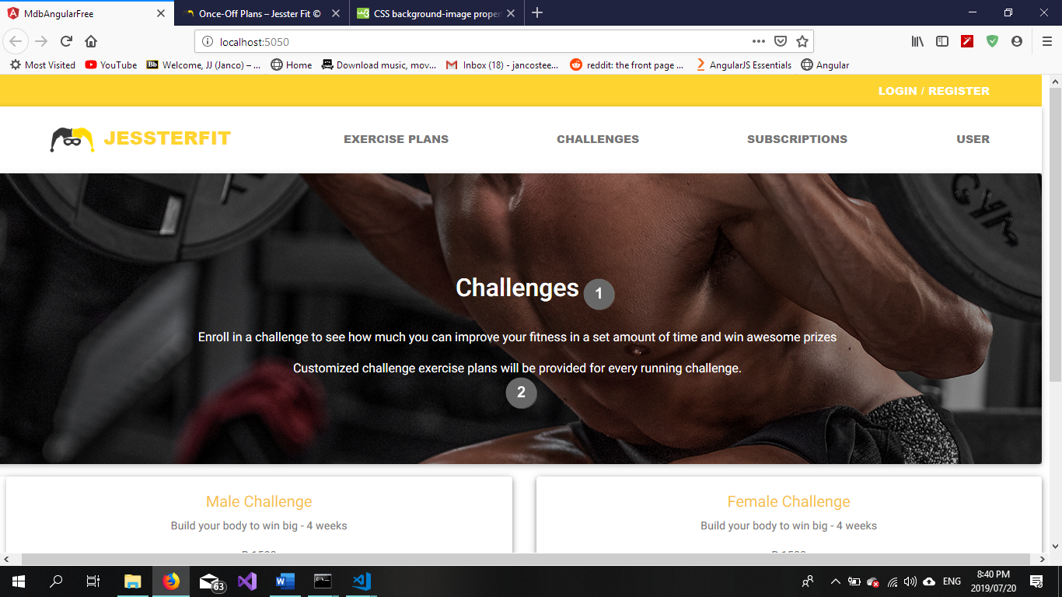

Figure 49 Register For A Challenge Part 1

|  |  |  |
| --- | --- | --- |
| **Screen Name: Register For A Challenge** | | |
| Item Num: | Item Name: | Item Description: |
| 1 | Challenges header | Descriptive element |
| 2 | Challenges Info | Descriptive element |

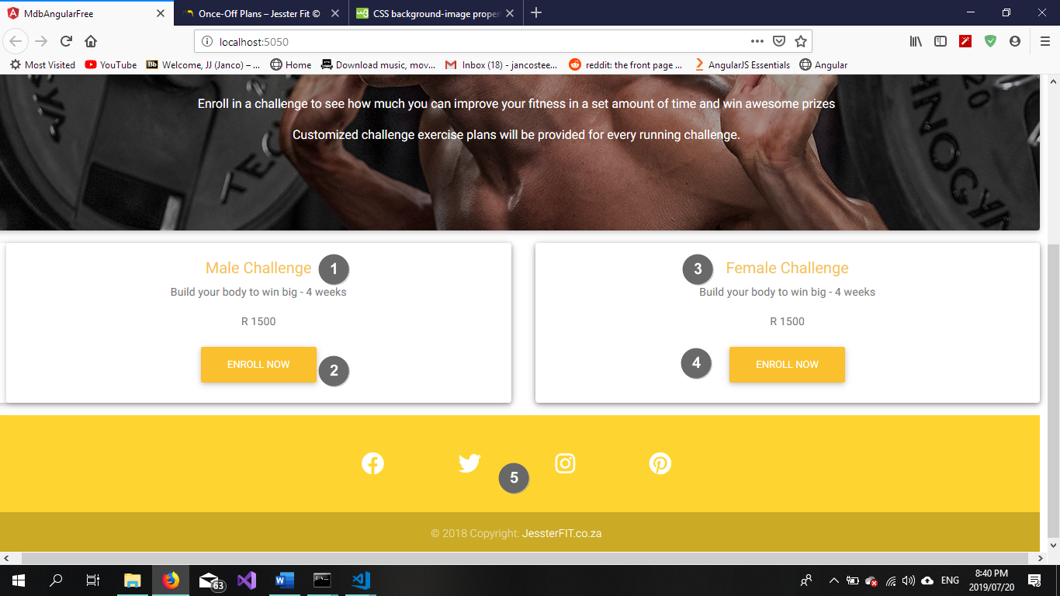

Figure 50 Register For A Challenge Part 2

|  |  |  |
| --- | --- | --- |
| **Screen Name: Register For A Challenge** | | |
| Item Num: | Item Name: | Item Description: |
| 1 | Male Challenge label | Descriptive element |
| 2 | Enrol Now button | Allows user to enrol for a challenge |
| 3 | Female Challenge label | Descriptive element |
| 4 | Enrol Now button | Allows user to enrol for a challenge |
| 5 | Assorted social media links | Links the user to the business’ social media accounts |

5.3.7 Use Case 3.7 – Purchase Exercise Plan

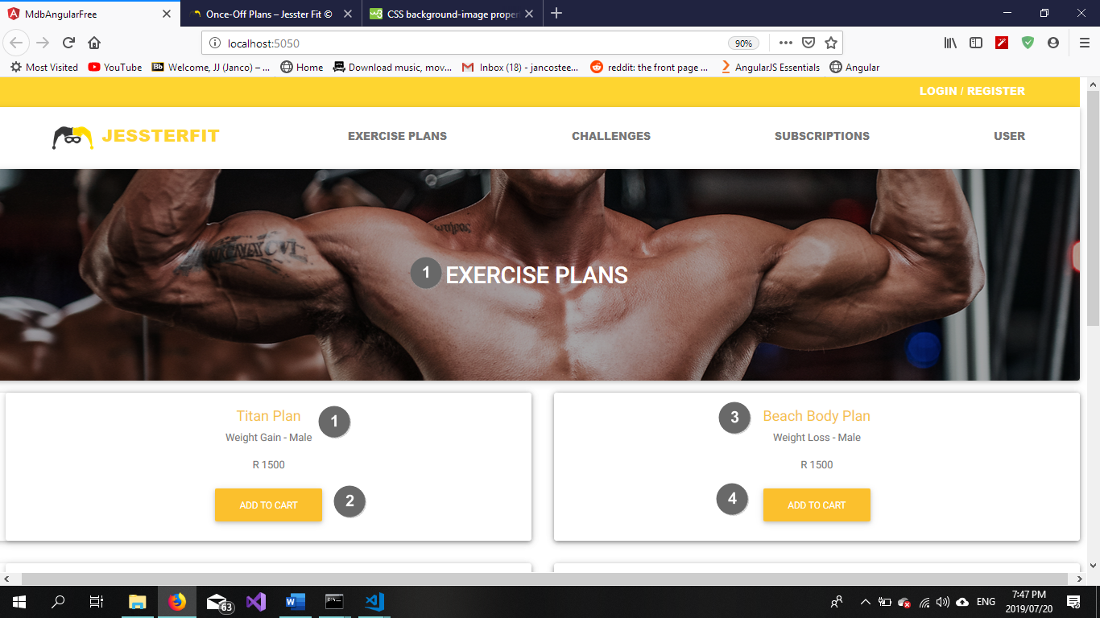

Figure 51 Purchase Exercise Plan Part 1

|  |  |  |
| --- | --- | --- |
| **Screen Name: Purchase Exercise Plan** | | |
| Item Num: | Item Name: | Item Description: |
| 1 | Exercise Plans label | Descriptive element |
| 1 | Titan Plan - Male label | Descriptive element |
| 2 | Add To Cart button | Allows user to add an exercise plan to their cart |
| 3 | Beach Body Plan - Male label | Descriptive element |
| 4 | Add To Cart button | Allows user to add an exercise plan to their cart |

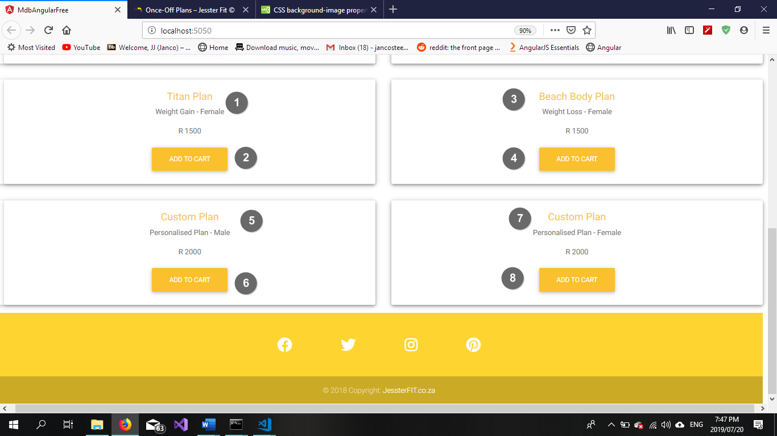

Figure 52 Purchase Exercise Plan Part 2

|  |  |  |
| --- | --- | --- |
| **Screen Name: Purchase Exercise plan** | | |
| Item Num: | Item Name: | Item Description: |
| 1 | Titan Plan - Female label | Descriptive element |
| 2 | Add To Cart button | Allows user to add an exercise plan to their cart |
| 3 | Beach Body Plan - Female label | Descriptive element |
| 4 | Add To Cart button | Allows user to add an exercise plan to their cart |
| 5 | Custom Plan – Male label | Descriptive element |
| 6 | Add To Cart button | Allows user to add an exercise plan to their cart |
| 7 | Custom Plan – Female label | Descriptive element |
| 8 | Add To Cart button | Allows user to add an exercise plan to their cart |

Client Landing Page

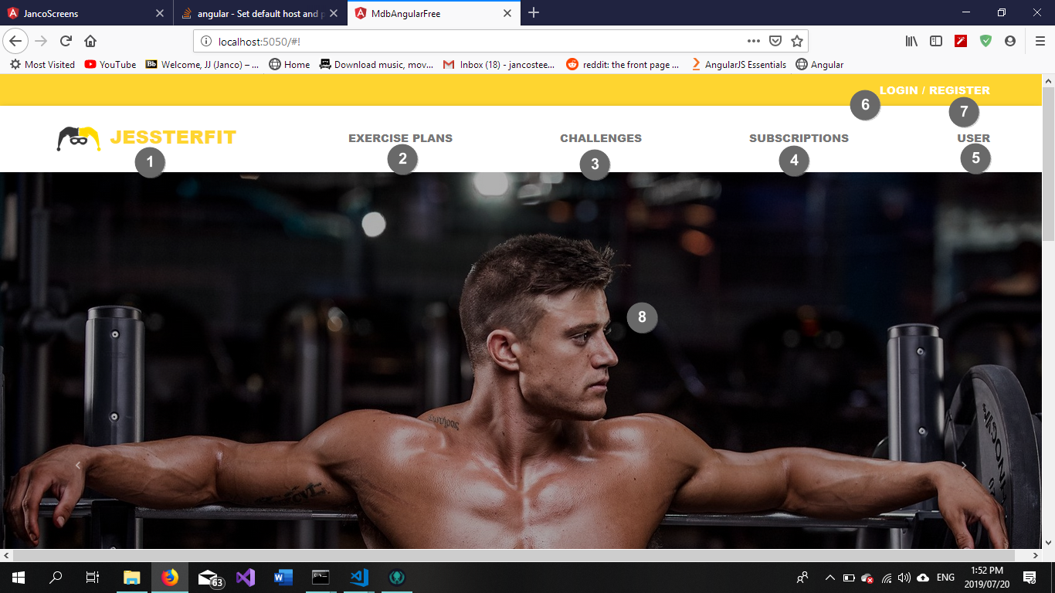

Figure 53 Home Screen Part 1

|  |  |  |
| --- | --- | --- |
| **Screen Name: Client Landing Page** | | |
| Item Num: | Item Name: | Item Description: |
| 1 | JessterFIT logo | Functions as a link to this page |
| 2 | Exercise Plan link | Allows user to navigate to the Exercise Plan screen |
| 3 | Challenges link | Allows user to navigate to the Challenges screen |
| 4 | Subscriptions link | Allows user to navigate to the Subscriptions screen |
| 5 | User link | Allows user to navigate to the Client Profile screen |
| 6 | Login link | Allows user to Login to the system |
| 7 | Register link | Allows the user to Register on the system |
| 8 | Background Image | Aesthetic element |

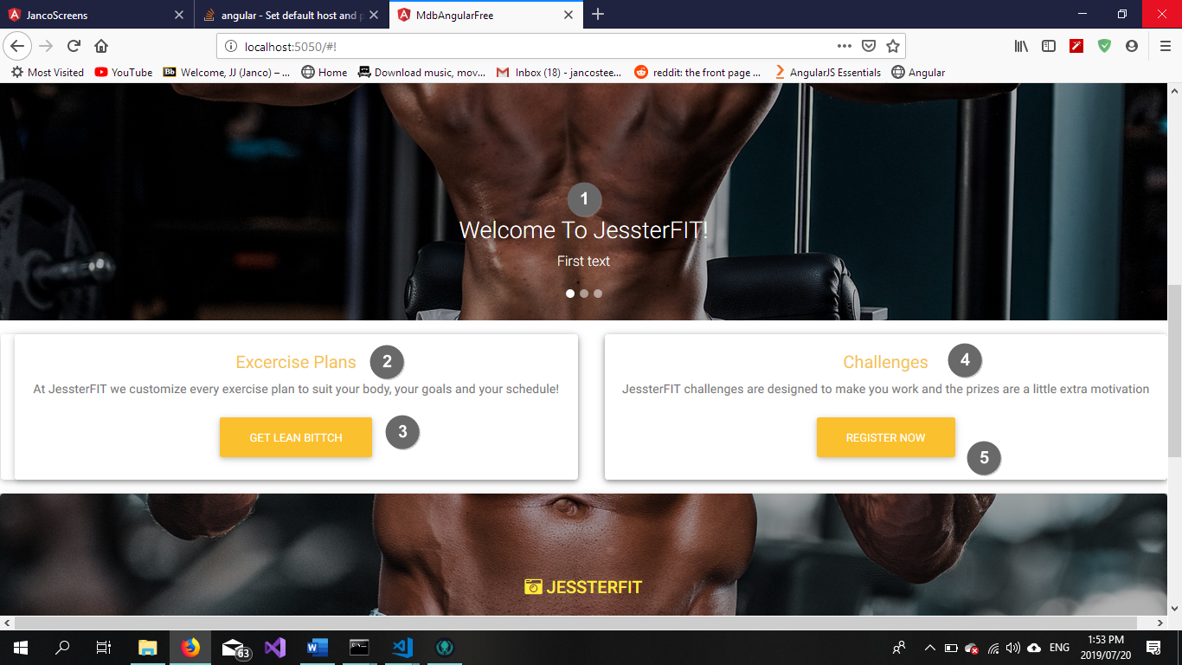

Figure 53 Home Screen Part 2

|  |  |  |
| --- | --- | --- |
| **Screen Name: Client Landing Page** | | |
| Item Num: | Item Name: | Item Description: |
| 1 | Welcome label | Descriptive element |
| 2 | Exercise Plan label | Descriptive element |
| 3 | Get Lean button | Allows user to navigate to the Exercise Plans screen |
| 4 | Challenges label | Descriptive element |
| 5 | Register Now button | Allows user to navigate to the Challenges screen |

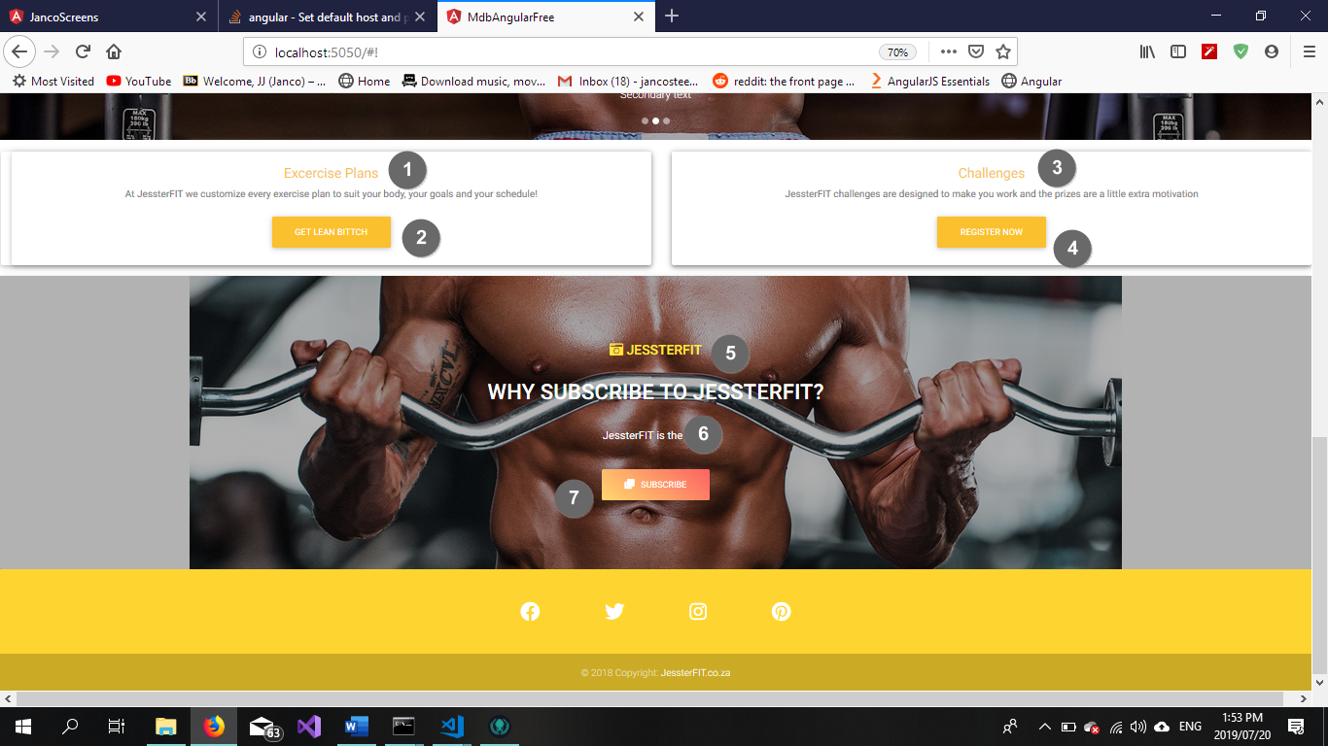

Figure 54 Home Screen Part 3

|  |  |  |
| --- | --- | --- |
| **Screen Name: Client Landing Page** | | |
| Item Num: | Item Name: | Item Description: |
| 1 | Exercise Plan label | Descriptive element |
| 2 | Get Lean button | Allows user to navigate to the Exercise Plans screen |
| 3 | Challenges label | Descriptive element |
| 4 | Register Now button | Allows user to navigate to the Challenges screen |
| 5 | JessterFIT logo | The business’ Instagram handle |
| 6 | JessterFIT label | Descriptive element |
| 7 | Subscribe button | Allows user to navigate to the Subscription Screen screen |

5.3.8 Use Case 3.8 – Make Payment

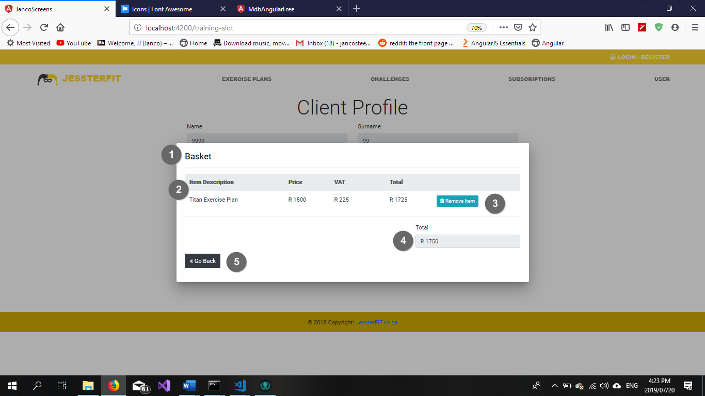

Figure 54 Basket

|  |  |  |
| --- | --- | --- |
| **Screen Name: Basket Screen** | | |
| Item Num: | Item Name: | Item Description: |
| 1 | Basket label | Descriptive element |
| 2 | Basket table | Displays all products currently in basket |
| 3 | Remove Item button | Allows users to remove items from their basket |
| 4 | Total control break | Displays sum of all basket items |
| 5 | JessterFIT logo | The business’ Instagram handle |
| 6 | Go back button | Allows user to navigate to a previous screen |

5.3.9 Use Case 3.9 – Make Personal Training Booking

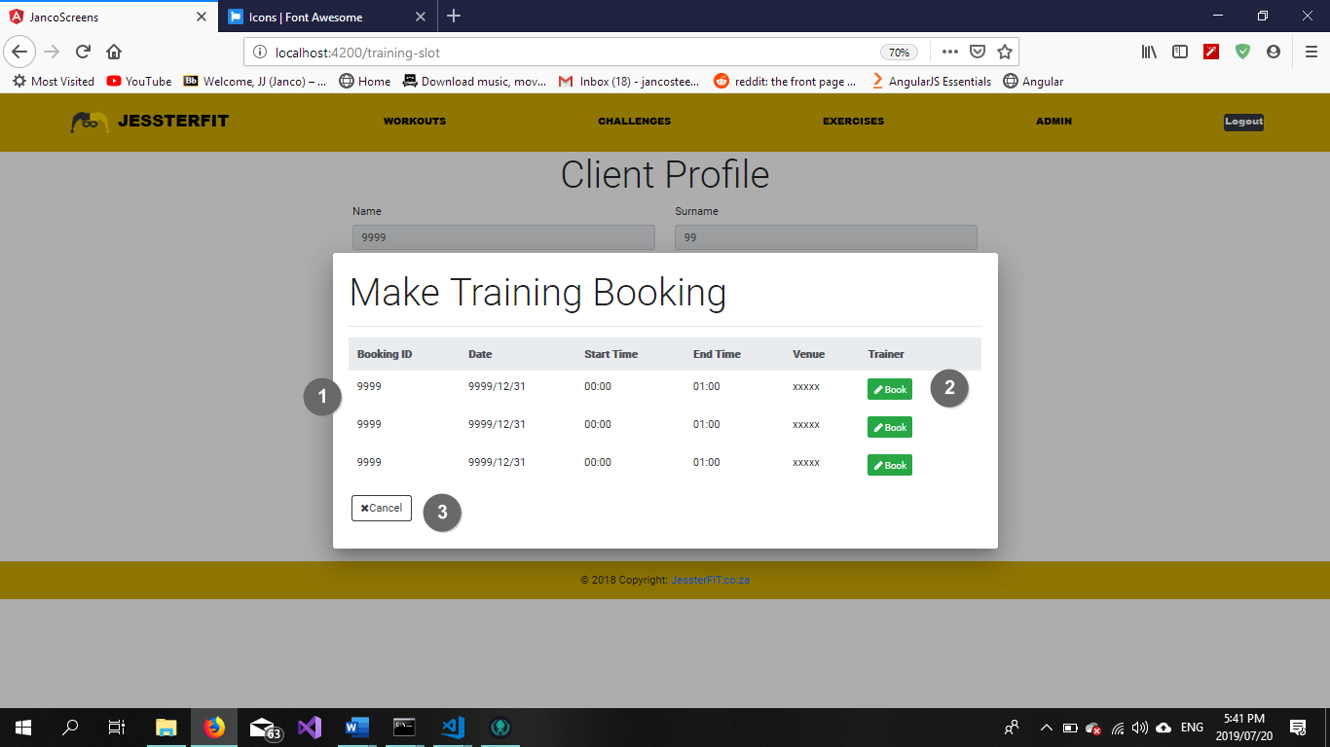

Figure 55 Make Training Booking

|  |  |  |
| --- | --- | --- |
| **Screen Name: Client Training Booking** | | |
| Item Num: | Item Name: | Item Description: |
| 1 | Available Personal Training Slots table | Displays all available booking slots |
| 2 | Book button | Allows the user to book an available slot |
| 3 | Cancel button | Allows users to cancel the booking action and closes the pop up |

5.3.11 Use Case 3.11 – Make New Consultation Booking

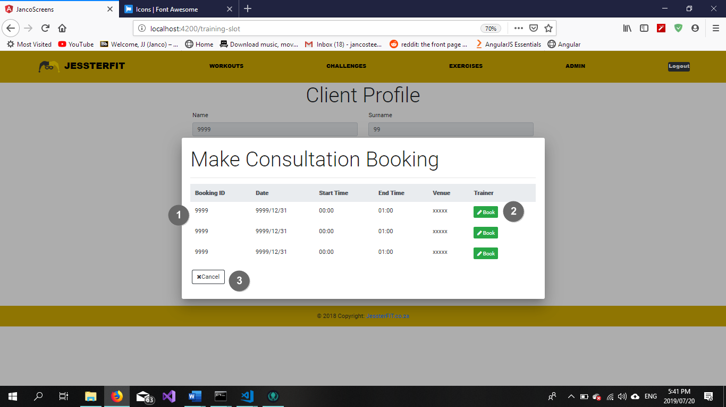

Figure 56 Consultation Booking

|  |  |  |
| --- | --- | --- |
| **Screen Name: Client Training Booking** | | |
| Item Num: | Item Name: | Item Description: |
| 1 | Available Consultation Slots table | Displays all available consultation slots |
| 2 | Book button | Allows the user to book an available slot |
| 3 | Cancel button | Allows users to cancel the booking action and closes the pop up |

* 5.3.14 Use Case 3.14 - Create Client Bio Form
* 5.3.15 Use Case 3.16 - Search Bio Form



Figure 57 Bio Form

|  |  |  |
| --- | --- | --- |
| **Screen Name: Client Bio Form Screen** | | |
| Item Num: | Item Name: | Item Description: |
| 1 | Client Bio Form heading | Descriptive element |
| 2 | Bio Form ID label | Descriptive element |
| 3 | Bio Form ID input box | Contains Bio Form ID |
| 4 | Client ID label | Descriptive element |
| 5 | Client ID input box | Contains Client ID |
| 6 | Height label | Descriptive element |
| 7 | Height input box | Contains Client Height |
| 8 | Date of Birth label | Descriptive element |
| 9 | Date of Birth input box (type=date) | Contains Client Date of birth |
| 10 | Weight label | Descriptive element |
| 11 | Weight input box | Contains Client Weight |
| 12 | Gender label | Descriptive element |
| 13 | Gender dropdown list | Contains Gender details |
| 14 | Injury label | Descriptive element |
| 15 | Injury input box | Contains Injury details |
| 16 | Add button | Adds the entered details to the database as a new record |
| 17 | Search textbox | A textbox which holds the search criteria for a challenge |
| 18 | Search button | Initiates the search function |
| 19 | Client Bio Form table | Contains all existing bio form information |
| 20 | Edit button | Initiates the maintain bio form function |
| 21 | Delete button | Removes the selected record from the database |

5.3.16 Create Client Bio Form (Success)



Figure 58 Success Message

|  |  |  |
| --- | --- | --- |
| **Popup Name: Blank Field(s) Error** | | |
| Item Num: | Item Name: | Item Description: |
| 1 | Information label | Displays information regarding current events |
| 2 | Back button | Returns user to a previous state |

5.3.17 Add Bio Form (Blank Fields)



Figure 59 Blank Field Error

|  |  |  |
| --- | --- | --- |
| **Popup Name: Blank Field(s) Error** | | |
| Item Num: | Item Name: | Item Description: |
| 1 | Information label | Displays information regarding current events |
| 2 | Back button | Returns user to a previous state |

5.3.18 Add Bio Form (Invalid Data)



Figure 60 Invalid Data Error

|  |  |  |
| --- | --- | --- |
| **Popup Name: Invalid Data Error** | | |
| Item Num: | Item Name: | Item Description: |
| 1 | Information label | Displays information regarding current events |
| 2 | Back button | Returns user to a previous state |

5.3.19 Search Booking Slot (No Records Found)



Figure 61 No Records Found Error

|  |  |  |
| --- | --- | --- |
| **Popup Name: No Records Found** | | |
| Item Num: | Item Name: | Item Description: |
| 1 | Information label | Displays information regarding current events |
| 2 | Back button | Navigates the user to a previous state |

5.3.20 Maintain Booking Slot (Delete Confirmation)



Figure 62 Delete Confirmation

|  |  |  |
| --- | --- | --- |
| **Popup Name: Confirm Delete** | | |
| Item Num: | Item Name: | Item Description: |
| 1 | Information label | Displays information regarding current events |
| 2 | Delete button | Confirms deletion of a record |
| 3 | Cancel button | Cancel the current action |

5.3.16 Use Case 3.16 – Maintain Bio Form



Figure 62 Maintain Bio Form

|  |  |  |
| --- | --- | --- |
| **Popup Name: Edit Bio Form** | | |
| Item Num: | Item Name: | Item Description: |
| 1 | Edit Client Bio Form heading | Descriptive element |
| 2 | Bio Form ID label | Descriptive element |
| 3 | Bio Form ID textbox | Contains Bio Form ID |
| 4 | Height label | Descriptive element |
| 5 | Height textbox | Contains Height |
| 6 | Gender label | Descriptive element |
| 7 | Gender textbox | Contains Gender |
| 8 | Client ID Label | Descriptive element |
| 9 | Client ID input box | Contains Client ID |
| 10 | Weight Label | Descriptive element |
| 11 | Weight input box | Contains Weight |
| 12 | Injury label | Descriptive element |
| 13 | Injury input box | Contains Injury of client |
| 14 | Submit button | Updates the entered details to the database |
| 15 | Close textbox | Cancels the action and closes the pop-up |

5.3.17 Use Case – 3.17 View Client Profile



Figure 63 Client Profile

|  |  |  |
| --- | --- | --- |
| **Screen Name: Client Profile** | | |
| Item Num: | Item Name: | Item Description: |
| 1 | Client Profile heading | Descriptive element |
| 2 | Name label | Descriptive element |
| 3 | Name input box | Contains client Name |
| 4 | Email label | Descriptive element |
| 5 | Email input box | Contains client Email |
| 6 | Gender label | Descriptive element |
| 7 | Gender drop down list | Contains customer Gender |
| 8 | Surname label | Descriptive element |
| 9 | Surname input box | Contains customer Surname |
| 10 | Subscription Status label | Descriptive element |
| 11 | Subscription Status input box | Contains client Subscription Status |
| 12 | Edit button | Initiates maintain client |
| 13 | Book Training button | Initiates make personal training booking |
| 14 | Book Consultation button | Initiates make consultation booking |
| 15 | Search textbox | A textbox which holds the search criteria for an employee |
| 16 | Client Profile table | Contains all existing client profile information |

## 5.4 Subsystem 4: User Subsystem

5.4.1 Use Case 4.1 – Log In

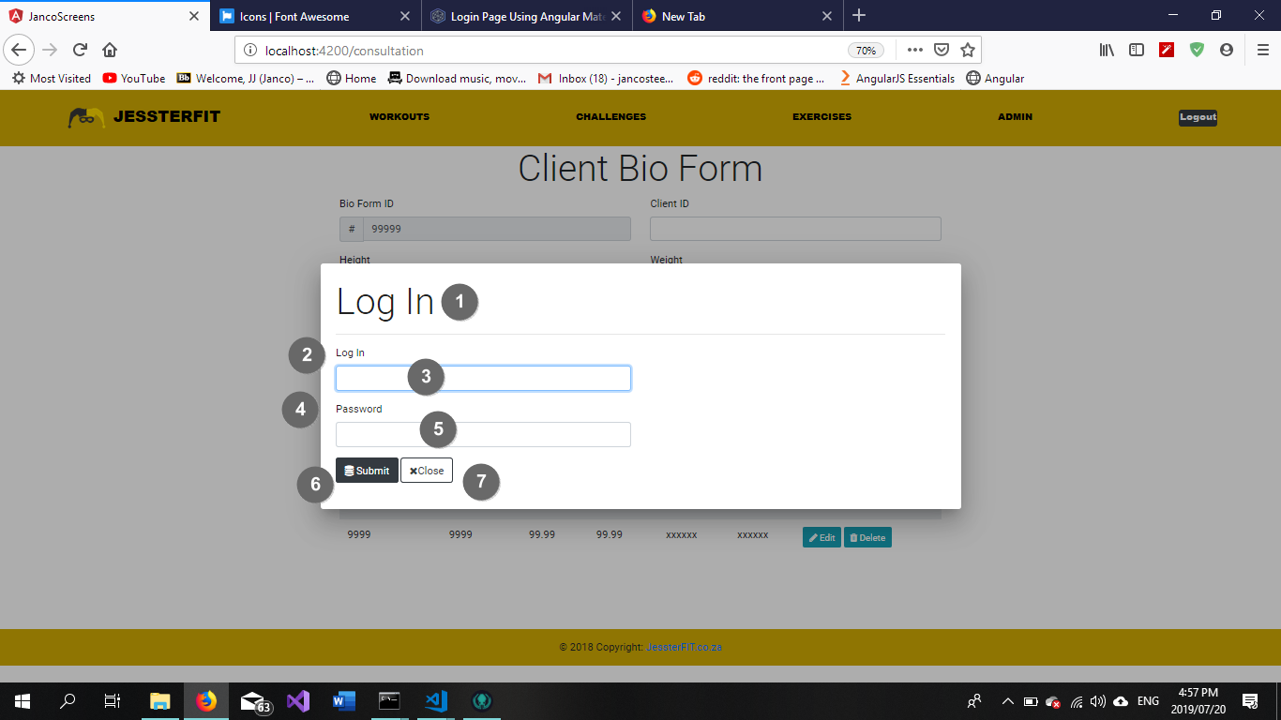

Figure 64 Log In

|  |  |  |
| --- | --- | --- |
| **Screen Name: Log In** | | |
| Item Num: | Item Name: | Item Description: |
| 1 | Log In heading | Descriptive element |
| 2 | Log In label | Descriptive element |
| 3 | Log In input box | Contains client Username |
| 4 | Password label | Descriptive element |
| 5 | Password input box | Contains client Password (hidden) |
| 6 | Submit button | Initiates the client log in process |
| 7 | Close button | Cancels the log in process and returns the user to their previous page |

5.4.3 Use Case 4.3 – Forgotten Password

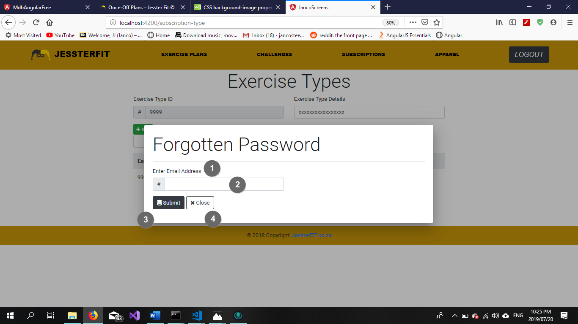

Figure 65 Forgotten Password

|  |  |  |
| --- | --- | --- |
| **Screen Name: Log In** | | |
| Item Num: | Item Name: | Item Description: |
| 1 | Enter Email Address label | Descriptive element |
| 2 | Enter Email Address input box | Contains the client Email Address used for password recovery |
| 3 | Submit button | Initiates the client password recovery process |
| 4 | Close button | Cancels the password recovery process and returns the user to their previous page |

5.4.4 Use Case 4.4 – Log Out

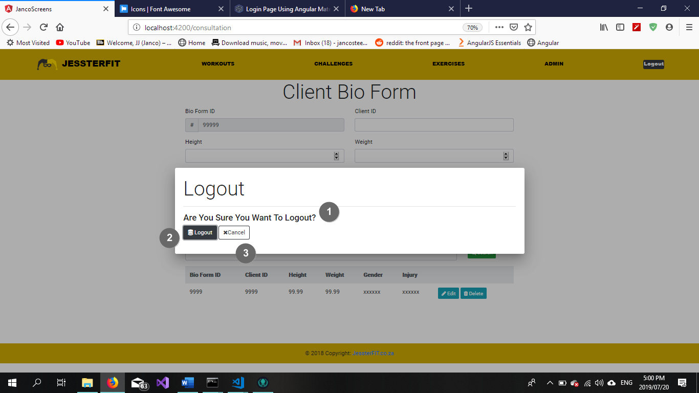

Figure 66 Log out

|  |  |  |
| --- | --- | --- |
| **Screen Name: Log In** | | |
| Item Num: | Item Name: | Item Description: |
| 1 | Are you sure you want to log out? label | Descriptive element |
| 2 | Logout button | Initiates the client logout process |
| 3 | Cancel button | Cancels the logout process and returns the user to their previous page |

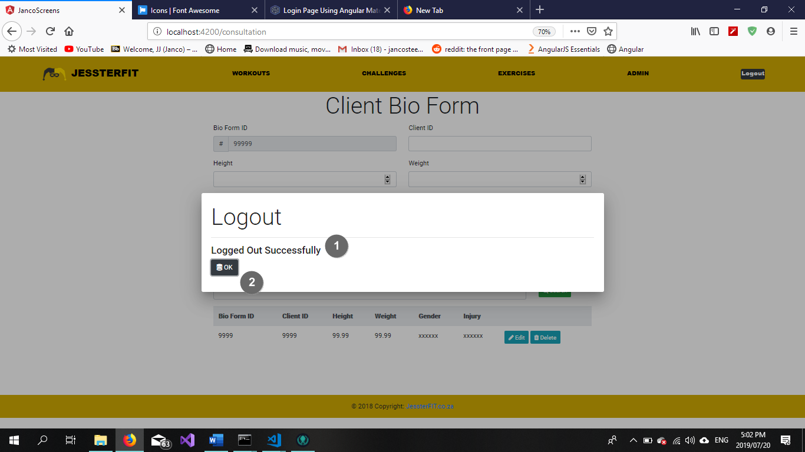

Figure 67 Log out confirmation

|  |  |  |
| --- | --- | --- |
| **Screen Name: Log In** | | |
| Item Num: | Item Name: | Item Description: |
| 1 | Logged out successfully label | Descriptive element |
| 2 | Ok button | Closes the pop up and navigates the user to the landing page |

* 5.4.5 Use Case 4.5 – Add New Access Level
* 5.4.6 Use Case 4.7 – Search Access Level

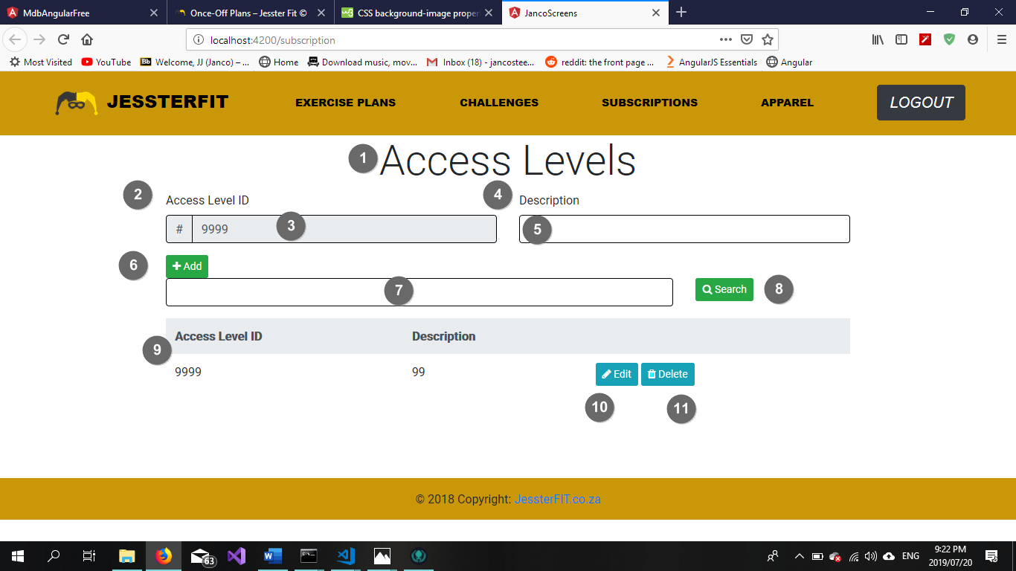

Figure 68 Add Access Level

|  |  |  |
| --- | --- | --- |
| **Screen Name: Add Access Level** | | |
| Item Num: | Item Name: | Item Description: |
| 1 | Access Levels heading | Descriptive element |
| 2 | Access Level ID label | Descriptive element |
| 3 | Access Level ID textbox | Contains Access Level ID |
| 4 | Access Level Description label | Descriptive element |
| 5 | Access Level Description textbox | Contains Access Level Description |
| 6 | Add button | Adds the record to the database |
| 7 | Search textbox | Search Criteria to be entered here |
| 8 | Search button | Clicking this button initiates the search function |
| 9 | Access Level Table | Displays all existing Access Level records |
| 10 | Edit button | Initiates the maintain access level function |
| 11 | Delete button | Delete a record from the database |

5.4.7 Use Case 4.6 – Maintain Access Level

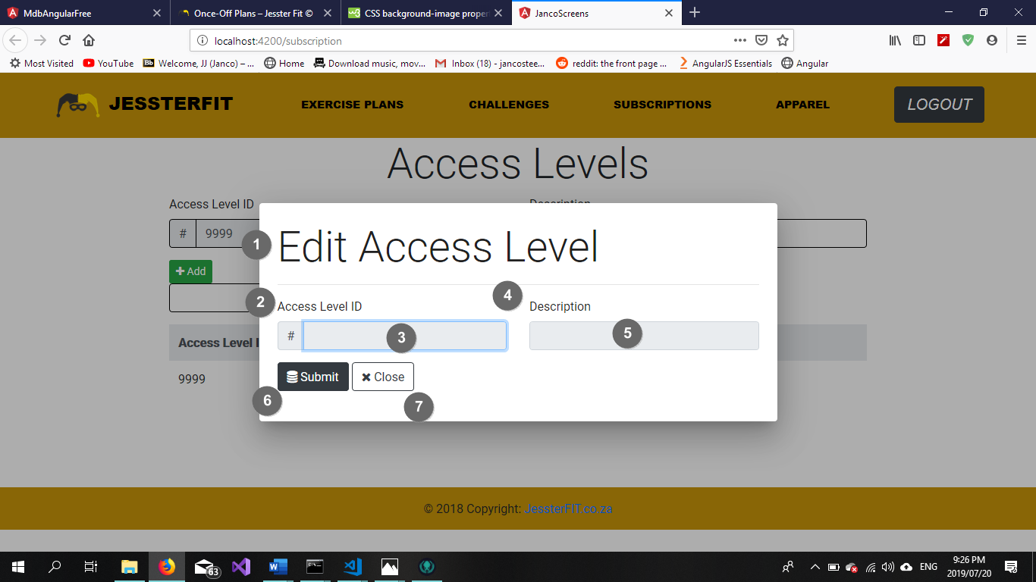

Figure 69 Maintain Access Level

|  |  |  |
| --- | --- | --- |
| **Popup Name: Maintain Access Level** | | |
| Item Num: | Item Name: | Item Description: |
| 1 | Edit Access Level heading | Descriptive element |
| 2 | Access Level ID label | Descriptive element |
| 3 | Access Level ID textbox | Contains Access Level ID |
| 4 | Description label | Descriptive element |
| 5 | Description textbox | Contains Access Level Description |
| 6 | Submit button | Update database with maintained details |
| 7 | Close button | Close pop-up and reverts any unsaved changes |

5.4.8 Add New Access Level (Success)



Figure 70 Success Message

|  |  |  |
| --- | --- | --- |
| **Popup Name: Blank Field(s) Error** | | |
| Item Num: | Item Name: | Item Description: |
| 1 | Information label | Displays information regarding current events |
| 2 | Back button | Returns user to a previous state |

5.4.9 Add New Access Level (Success)



Figure 71 Blank Field Error

|  |  |  |
| --- | --- | --- |
| **Popup Name: Blank Field(s) Error** | | |
| Item Num: | Item Name: | Item Description: |
| 1 | Information label | Displays information regarding current events |
| 2 | Back button | Returns user to a previous state |

5.4.10 Add New Access Level (Success)



Figure 72 Invalid Data Error

|  |  |  |
| --- | --- | --- |
| **Popup Name: Invalid Data Error** | | |
| Item Num: | Item Name: | Item Description: |
| 1 | Information label | Displays information regarding current events |
| 2 | Back button | Returns user to a previous state |

5.4.11 Search Access Level (No Records Found)



Figure 73 No Records Found Error

|  |  |  |
| --- | --- | --- |
| **Popup Name: No Records Found** | | |
| Item Num: | Item Name: | Item Description: |
| 1 | Information label | Displays information regarding current events |
| 2 | Back button | Navigates the user to a previous state |

5.4.12 Maintain Access Level (Delete Confirmation)



Figure 74 Delete Confirmation

|  |  |  |
| --- | --- | --- |
| **Popup Name: Confirm Delete** | | |
| Item Num: | Item Name: | Item Description: |
| 1 | Information label | Displays information regarding current events |
| 2 | Delete button | Confirms deletion of a record |
| 3 | Cancel button | Cancel the current action |

* 5.4.8 Use Case 4.8 – Add Functionality
* 5.4.9 Use Case 4.10 – Search Functionality

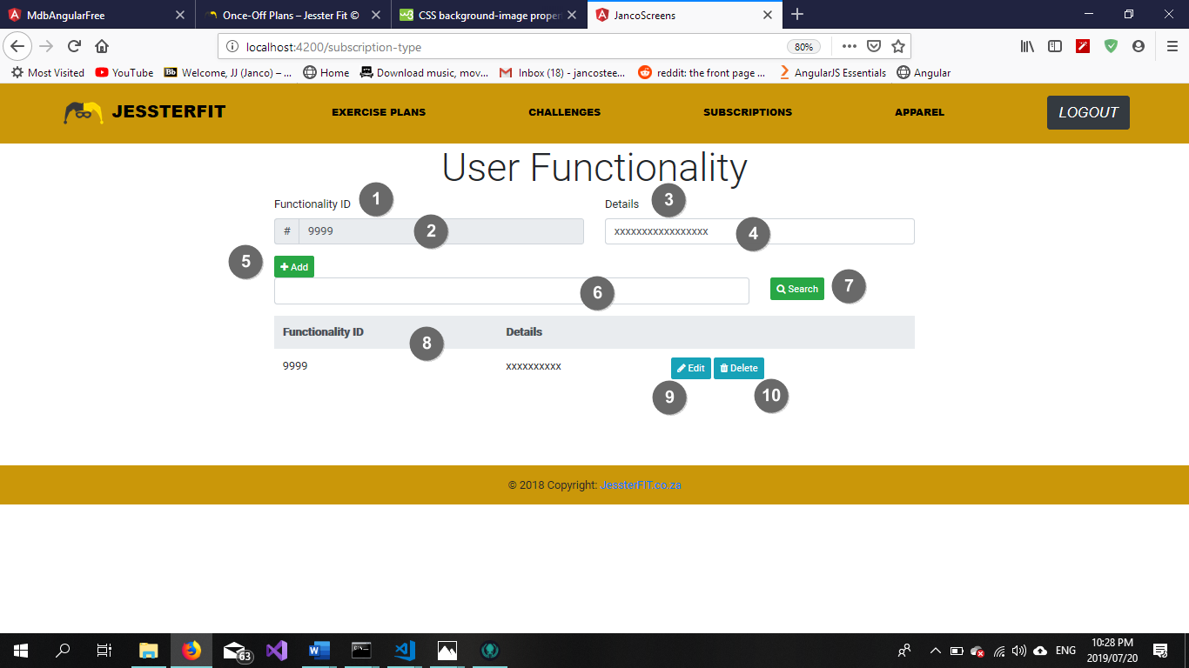

Figure 75 Add Functionality

|  |  |  |
| --- | --- | --- |
| **Screen Name: Add Functionality** | | |
| Item Num: | Item Name: | Item Description: |
| 1 | Functionality ID label | Descriptive element |
| 2 | Functionality ID textbox | Contains Functionality ID |
| 3 | Details label | Descriptive element |
| 4 | Details textbox | Contains Functionality Details |
| 5 | Add button | Adds the record to the database |
| 6 | Search textbox | Search Criteria to be entered here |
| 7 | Search button | Clicking this button initiates the search function |
| 8 | Functionality Table | Displays all existing Functionality records |
| 9 | Edit button | Initiates the maintain access level function |
| 10 | Delete button | Delete a record from the database |

5.4.10 Use Case – Maintain Functionality

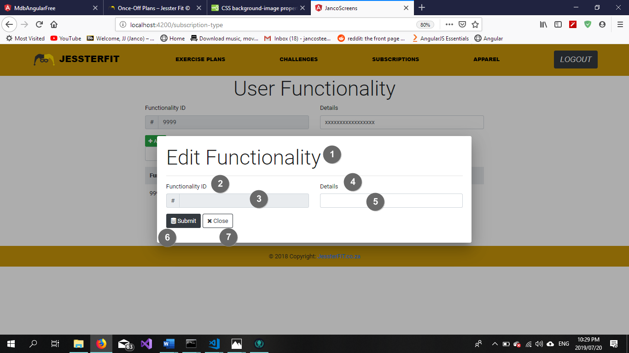

Figure 76 Maintain functionality

|  |  |  |
| --- | --- | --- |
| **Popup Name: Maintain Functionality** | | |
| Item Num: | Item Name: | Item Description: |
| 1 | Edit Functionality heading | Descriptive element |
| 2 | Functionality ID label | Descriptive element |
| 3 | Functionality ID textbox | Contains Functionality ID |
| 4 | Details label | Descriptive element |
| 5 | Details textbox | Contains Functionality Details |
| 6 | Submit button | Update database with maintained details |
| 7 | Close button | Close pop-up and reverts any unsaved changes |

5.4.11 Add New Functionality (Success)



Figure 77 Success Message

|  |  |  |
| --- | --- | --- |
| **Popup Name: Blank Field(s) Error** | | |
| Item Num: | Item Name: | Item Description: |
| 1 | Information label | Displays information regarding current events |
| 2 | Back button | Returns user to a previous state |

5.4.12 Add New Functionality (Success)



Figure 78 Blank Field Error

|  |  |  |
| --- | --- | --- |
| **Popup Name: Blank Field(s) Error** | | |
| Item Num: | Item Name: | Item Description: |
| 1 | Information label | Displays information regarding current events |
| 2 | Back button | Returns user to a previous state |

5.4.13 Add New Functionality (Success)



Figure 79 Invalid Data Error

|  |  |  |
| --- | --- | --- |
| **Popup Name: Invalid Data Error** | | |
| Item Num: | Item Name: | Item Description: |
| 1 | Information label | Displays information regarding current events |
| 2 | Back button | Returns user to a previous state |

5.4.14 Search Functionality (No Records Found)



Figure 80 No Records Found Error

|  |  |  |
| --- | --- | --- |
| **Popup Name: No Records Found** | | |
| Item Num: | Item Name: | Item Description: |
| 1 | Information label | Displays information regarding current events |
| 2 | Back button | Navigates the user to a previous state |

5.4.15 Maintain Functionality (Delete Confirmation)



Figure 81 Delete Confirmation

|  |  |  |
| --- | --- | --- |
| **Popup Name: Confirm Delete** | | |
| Item Num: | Item Name: | Item Description: |
| 1 | Information label | Displays information regarding current events |
| 2 | Delete button | Confirms deletion of a record |
| 3 | Cancel button | Cancel the current action |

## 5.6 Subsystem 6: Exercise Subsystem

* 5.6.1 Use Case 6.1 – Add New Exercise Plan Type
* 5.6.2 Use Case 6.3 – Search Exercise Plan Type

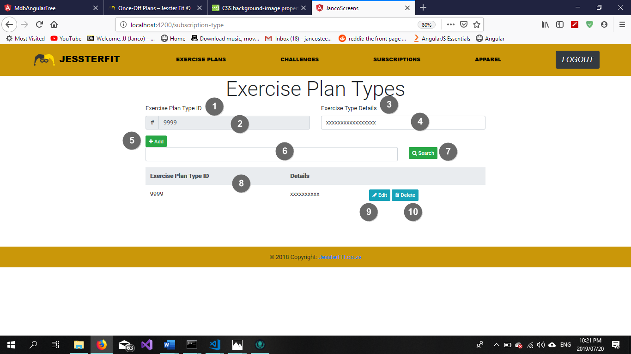

Figure 82 Add new exercise plan

|  |  |  |
| --- | --- | --- |
| **Screen Name: Add Exercise Plan Type** | | |
| Item Num: | Item Name: | Item Description: |
| 1 | Exercise Plan Type ID label | Descriptive element |
| 2 | Exercise Plan Type ID textbox | Contains Exercise Plan Type ID |
| 3 | Exercise Plan Type Details label | Descriptive element |
| 4 | Exercise Plan Type Details textbox | Contains Exercise Plan Type Details |
| 5 | Add button | Adds the record to the database |
| 6 | Search textbox | Search Criteria to be entered here |
| 7 | Search button | Clicking this button initiates the search function |
| 8 | Exercise Plan Type Table | Displays all existing exercise plan type records |
| 9 | Edit button | Initiates the maintain exercise plan type function |
| 10 | Delete button | Delete a record from the database |

5.6.3 Use Case 6.2 – Maintain Exercise Plan Type

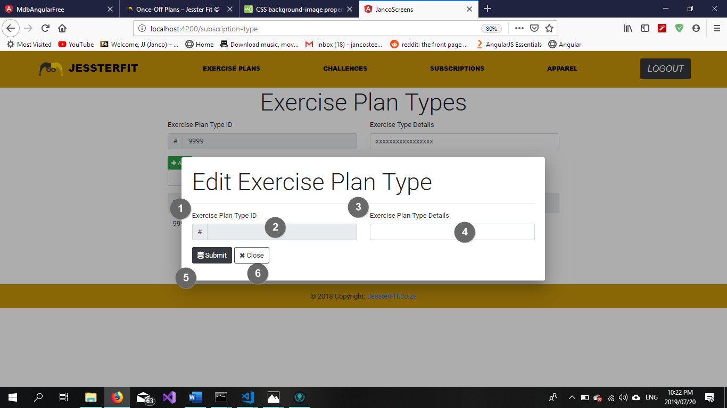

Figure 83 Maintain exercise plan type

|  |  |  |
| --- | --- | --- |
| **Popup Name: Maintain Exercise Plan Type** | | |
| Item Num: | Item Name: | Item Description: |
| 1 | Exercise Plan ID label | Descriptive element |
| 2 | Exercise Plan ID textbox | Contains Exercise Plan Type ID |
| 3 | Exercise Plan Type Details label | Descriptive element |
| 4 | Exercise Plan Type Details textbox | Contains Exercise Plan Type Details |
| 5 | Submit button | Update database with maintained details |
| 6 | Close button | Close pop-up and reverts any unsaved changes |

5.6.4 Add New Exercise Plan Type (Success)



Figure 84 Success Message

|  |  |  |
| --- | --- | --- |
| **Popup Name: Blank Field(s) Error** | | |
| Item Num: | Item Name: | Item Description: |
| 1 | Information label | Displays information regarding current events |
| 2 | Back button | Returns user to a previous state |

5.6.5 Add New Exercise Plan Type (Success)



Figure 85 Blank Field Error

|  |  |  |
| --- | --- | --- |
| **Popup Name: Blank Field(s) Error** | | |
| Item Num: | Item Name: | Item Description: |
| 1 | Information label | Displays information regarding current events |
| 2 | Back button | Returns user to a previous state |

5.6.6 Add New Exercise Plan Type (Success)



Figure 86 Invalid Data Error

|  |  |  |
| --- | --- | --- |
| **Popup Name: Invalid Data Error** | | |
| Item Num: | Item Name: | Item Description: |
| 1 | Information label | Displays information regarding current events |
| 2 | Back button | Returns user to a previous state |

5.6.7 Search Exercise Plan Type (No Records Found)



Figure 87 No Records Found Error

|  |  |  |
| --- | --- | --- |
| **Popup Name: No Records Found** | | |
| Item Num: | Item Name: | Item Description: |
| 1 | Information label | Displays information regarding current events |
| 2 | Back button | Navigates the user to a previous state |

5.6.8 Maintain Exercise Plan Type (Delete Confirmation)



Figure 88 Delete Confirmation

|  |  |  |
| --- | --- | --- |
| **Popup Name: Confirm Delete** | | |
| Item Num: | Item Name: | Item Description: |
| 1 | Information label | Displays information regarding current events |
| 2 | Delete button | Confirms deletion of a record |
| 3 | Cancel button | Cancel the current action |

* 5.6.9 Use Case 6.4 – Add New Exercise Type
* 5.6.10 Use Case 6.6 – Search Exercise Type

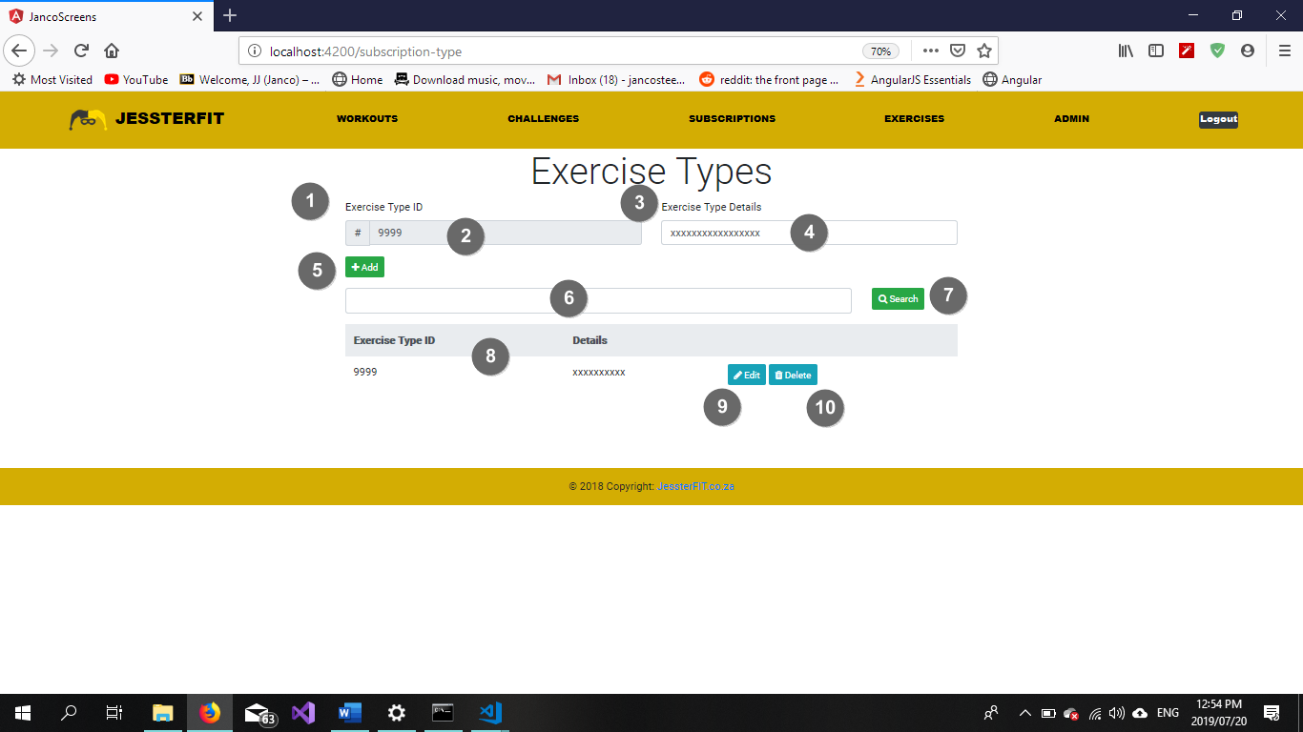

Figure 89 Add exercise Type

|  |  |  |
| --- | --- | --- |
| **Screen Name: Add Exercise Type** | | |
| Item Num: | Item Name: | Item Description: |
| 1 | Exercise Type ID label | Descriptive element |
| 2 | Exercise Type ID textbox | Contains Exercise Type ID |
| 3 | Exercise Type Details label | Descriptive element |
| 4 | Exercise Type Details textbox | Contains Exercise Type Details |
| 5 | Add button | Adds the record to the database |
| 6 | Search textbox | Search Criteria to be entered here |
| 7 | Search button | Clicking this button initiates the search function |
| 8 | Exercise Type Table | Displays all existing exercise type records |
| 9 | Edit button | Initiates the maintain exercise type function |
| 10 | Delete button | Delete a record from the database |

5.6.11 Use Case 6.5 – Maintain Exercise Type

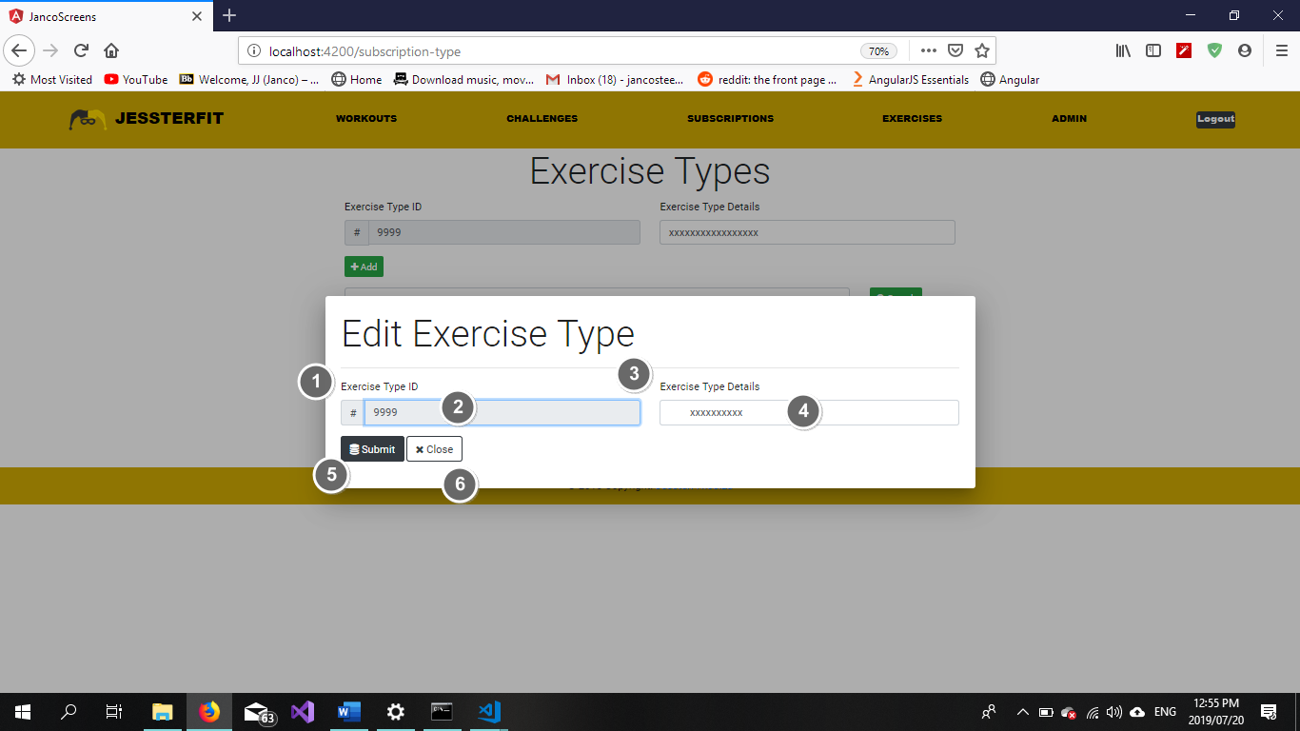

Figure 90 Maintain exercise type

|  |  |  |
| --- | --- | --- |
| **Popup Name: Maintain Exercise Type** | | |
| Item Num: | Item Name: | Item Description: |
| 1 | Exercise Type ID label | Descriptive element |
| 2 | Exercise Type ID textbox | Contains Exercise Type ID |
| 3 | Exercise Type Details label | Descriptive element |
| 4 | Exercise Type Details textbox | Contains Exercise Type Details |
| 5 | Submit button | Update database with maintained details |
| 6 | Close button | Close pop-up and reverts any unsaved changes |

5.6.12 Add New Exercise Type (Success)



Figure 91 Success Message

|  |  |  |
| --- | --- | --- |
| **Popup Name: Blank Field(s) Error** | | |
| Item Num: | Item Name: | Item Description: |
| 1 | Information label | Displays information regarding current events |
| 2 | Back button | Returns user to a previous state |

5.6.13 Add New Exercise Type (Success)



Figure 92 Blank Field Error

|  |  |  |
| --- | --- | --- |
| **Popup Name: Blank Field(s) Error** | | |
| Item Num: | Item Name: | Item Description: |
| 1 | Information label | Displays information regarding current events |
| 2 | Back button | Returns user to a previous state |

5.6.14 Add New Exercise Type (Success)



Figure 93 Invalid Data Error

|  |  |  |
| --- | --- | --- |
| **Popup Name: Invalid Data Error** | | |
| Item Num: | Item Name: | Item Description: |
| 1 | Information label | Displays information regarding current events |
| 2 | Back button | Returns user to a previous state |

5.6.15 Search Exercise Type (No Records Found)



Figure 94 No Records Found Error

|  |  |  |
| --- | --- | --- |
| **Popup Name: No Records Found** | | |
| Item Num: | Item Name: | Item Description: |
| 1 | Information label | Displays information regarding current events |
| 2 | Back button | Navigates the user to a previous state |

5.6.16 Maintain Exercise Type (Delete Confirmation)



Figure 95 Delete Confirmation

|  |  |  |
| --- | --- | --- |
| **Popup Name: Confirm Delete** | | |
| Item Num: | Item Name: | Item Description: |
| 1 | Information label | Displays information regarding current events |
| 2 | Delete button | Confirms deletion of a record |
| 3 | Cancel button | Cancel the current action |

* 5.6.17 Use Case 6.14 – Add New Exercise
* 5.6.18 Use Case 6.16 – Search Exercise

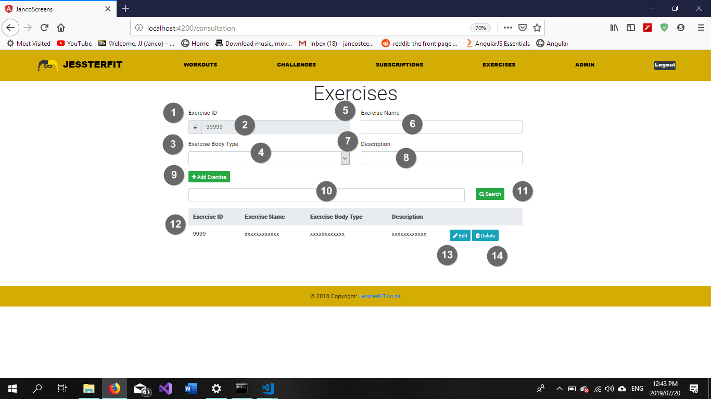

Figure 96 Add new exercise

|  |  |  |
| --- | --- | --- |
| **Screen Name: Add Exercise** | | |
| Item Num: | Item Name: | Item Description: |
| 1 | Exercise ID label | Descriptive element |
| 2 | Exercise ID textbox | Contains Exercise ID |
| 3 | Exercise Body Type label | Descriptive element |
| 4 | Exercise Body Type dropdown list | Contains a list of Exercise Body Types |
| 5 | Exercise Name label | Descriptive element |
| 6 | Exercise Name textbox | Contains Exercise Name |
| 7 | Description label | Descriptive element |
| 8 | Description textbox | Contains Exercise Description |
| 9 | Add button | Adds the record to the database |
| 10 | Search textbox | Search Criteria to be entered here |
| 11 | Search button | Clicking this button initiates the search function |
| 12 | Exercise Type Table | Displays all existing exercise records |
| 13 | Edit button | Initiates the maintain exercise function |
| 14 | Delete button | Delete a record from the database |

5.6.19 Use Case 6.15 – Maintain Exercise

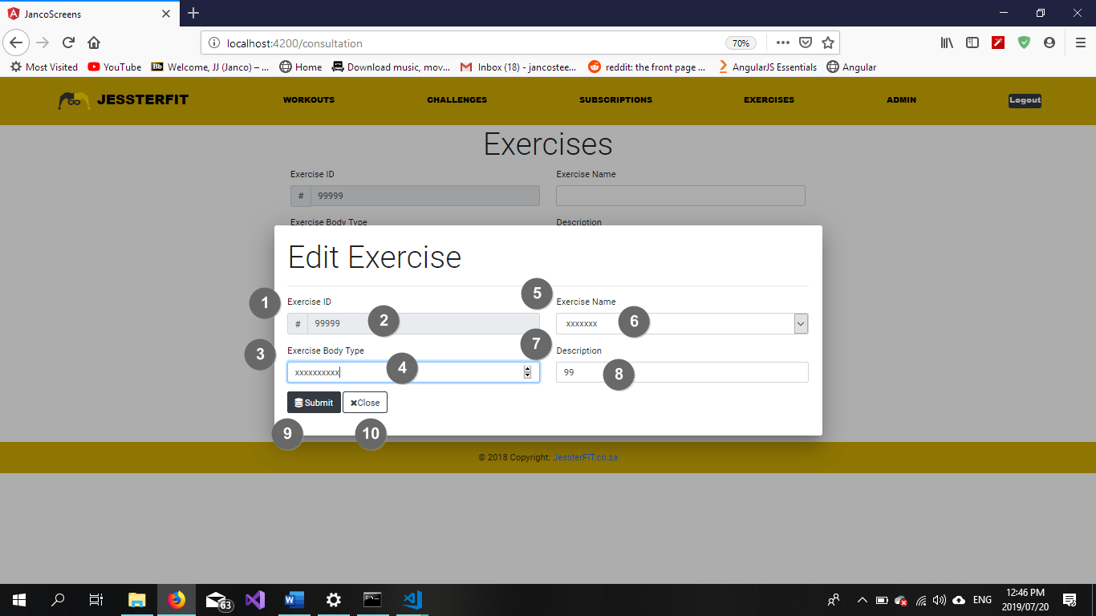

Figure 97 Maintain exercise

|  |  |  |
| --- | --- | --- |
| **Popup Name: Maintain Exercise** | | |
| Item Num: | Item Name: | Item Description: |
| 1 | Exercise ID label | Descriptive element |
| 2 | Exercise ID textbox | Contains Exercise ID |
| 3 | Exercise Body Type label | Descriptive element |
| 4 | Exercise Body Type dropdown list | Contains Exercise Body Type |
| 5 | Exercise Name label | Descriptive element |
| 6 | Exercise Name textbox | Contains Exercise Name |
| 7 | Description label | Descriptive element |
| 8 | Description textbox | Contains Exercise Description |
| 9 | Submit button | Update database with maintained details |
| 10 | Close button | Close pop-up and reverts any unsaved changes |

5.6.20 Add New Exercise (Success)



Figure 98 Success Message

|  |  |  |
| --- | --- | --- |
| **Popup Name: Blank Field(s) Error** | | |
| Item Num: | Item Name: | Item Description: |
| 1 | Information label | Displays information regarding current events |
| 2 | Back button | Returns user to a previous state |

5.6.21 Add New Exercise (Success)



Figure 99 Blank Field Error

|  |  |  |
| --- | --- | --- |
| **Popup Name: Blank Field(s) Error** | | |
| Item Num: | Item Name: | Item Description: |
| 1 | Information label | Displays information regarding current events |
| 2 | Back button | Returns user to a previous state |

5.6.22 Add New Exercise (Success)



Figure 100 Invalid Data Error

|  |  |  |
| --- | --- | --- |
| **Popup Name: Invalid Data Error** | | |
| Item Num: | Item Name: | Item Description: |
| 1 | Information label | Displays information regarding current events |
| 2 | Back button | Returns user to a previous state |

5.6.23 Search Exercise (No Records Found)



Figure 101 No Records Found Error

|  |  |  |
| --- | --- | --- |
| **Popup Name: No Records Found** | | |
| Item Num: | Item Name: | Item Description: |
| 1 | Information label | Displays information regarding current events |
| 2 | Back button | Navigates the user to a previous state |

5.6.24 Maintain Exercise (Delete Confirmation)



Figure 102 Delete Confirmation

|  |  |  |
| --- | --- | --- |
| **Popup Name: Confirm Delete** | | |
| Item Num: | Item Name: | Item Description: |
| 1 | Information label | Displays information regarding current events |
| 2 | Delete button | Confirms deletion of a record |
| 3 | Cancel button | Cancel the current action |

* 5.6.24 Use Case 6.17 - Add New Workout / Use Case 6.23 – Create Workot
* 5.6.25 Use Case 6.19 – Search Workout

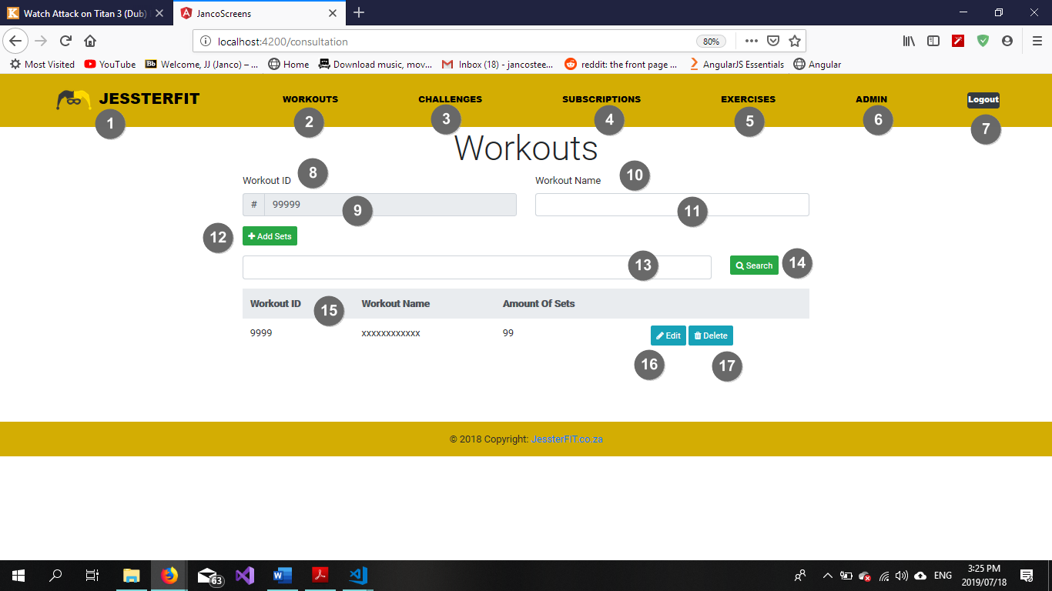

Figure 103 Add new workout

|  |  |  |
| --- | --- | --- |
| **Screen Name: Add/Create Workout** | | |
| Item Num: | Item Name: | Item Description: |
| 1 | JessterFIT logo | Allows the user to navigate to the home page |
| 2 | Workouts link | Allows the user to navigate to the Workout screen |
| 3 | Challenges link | Allows the user to navigate to the Challenges screen |
| 4 | Subscriptions link | Allows the user to navigate to the Subscriptions screen |
| 5 | Exercises link | Allows the user to navigate to the Exercises screen |
| 6 | Admin link | Allows the user to navigate to the Admin screen |
| 7 | Logout button | Allows the user to be logged out of the system |
| 8 | Workout ID label | Descriptive element |
| 9 | Workout ID textbox | Contains Workout ID |
| 10 | Workout Name label | Descriptive element |
| 11 | Workout Name textbox | Contains Workout Name |
| 12 | Add button | Adds the record to the database |
| 13 | Search textbox | Search Criteria to be entered here |
| 14 | Search button | Clicking this button initiates the search function |
| 15 | Exercise Type Table | Displays all existing exercise records |
| 16 | Edit button | Initiates the maintain exercise function |
| 17 | Delete button | Delete a record from the database |

* 5.6.26 Use Case 6.7 – Add New Rep
* 5.6.27 Use Case 6.8 – Maintain Rep
* 5.6.28 Use Case 6.9 – Add New Set
* 5.6.29 Use Case 6.10 – Maintain Set

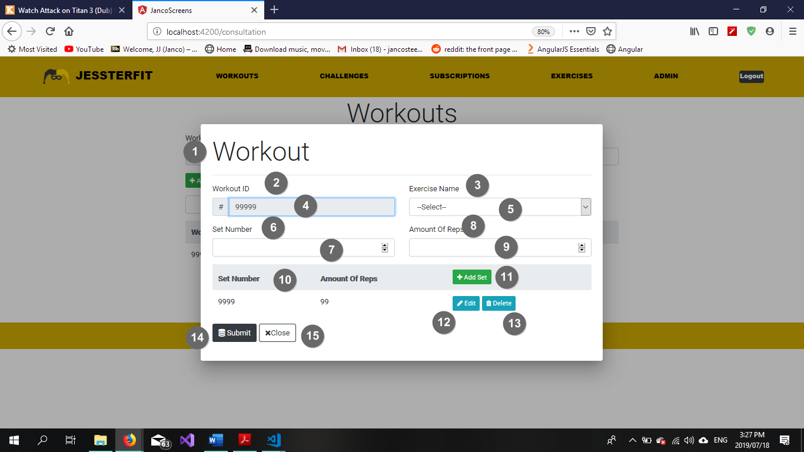

Figure 104 Add Rep/Set/Workout

|  |  |  |
| --- | --- | --- |
| **Popup Name: Add/Create Workout** | | |
| Item Num: | Item Name: | Item Description: |
| 1 | Workout header | Descriptive element |
| 2 | Workout ID label | Descriptive element |
| 3 | Exercise Name label | Descriptive element |
| 4 | Workout ID textbox | Contains Workout ID |
| 5 | Exercise Name dropdown list | Contains Exercise Names |
| 6 | Set Number label | Descriptive element |
| 7 | Set Number input box (type=number) | Contains Set Number |
| 8 | Amount of Reps label | Descriptive element |
| 9 | Amount of Reps input box (type=number) | Contains Amount of Reps per Set |
| 10 | Sets table | Displays existing Sets with accompanying Reps |
| 11 | Add Set button | Adds the Set and accompanying Reps to the database |
| 12 | Edit button | Allows the user to edit the record |
| 13 | Delete button | Delete a record from the database |
| 14 | Submit button | Adds the Workout to the database |
| 15 | Cancel button | Cancels operation and closes the pop up |

5.6.31 Add New Workout (Success)

Figure 105 Success Message

|  |  |  |
| --- | --- | --- |
| **Popup Name: Blank Field(s) Error** | | |
| Item Num: | Item Name: | Item Description: |
| 1 | Information label | Displays information regarding current events |
| 2 | Back button | Returns user to a previous state |

5.6.32 Add New Workout (Success)



Figure 106 Blank Field Error

|  |  |  |
| --- | --- | --- |
| **Popup Name: Blank Field(s) Error** | | |
| Item Num: | Item Name: | Item Description: |
| 1 | Information label | Displays information regarding current events |
| 2 | Back button | Returns user to a previous state |

5.6.33 Add New Workout (Success)



Figure 107 Invalid Data Error

|  |  |  |
| --- | --- | --- |
| **Popup Name: Invalid Data Error** | | |
| Item Num: | Item Name: | Item Description: |
| 1 | Information label | Displays information regarding current events |
| 2 | Back button | Returns user to a previous state |

5.6.34 Search Exercise (No Records Found)



Figure 108 No Records Found Error

|  |  |  |
| --- | --- | --- |
| **Popup Name: No Records Found** | | |
| Item Num: | Item Name: | Item Description: |
| 1 | Information label | Displays information regarding current events |
| 2 | Back button | Navigates the user to a previous state |

5.6.35 Maintain Workout (Delete Confirmation)



Figure 109 Delete Confirmation

|  |  |  |
| --- | --- | --- |
| **Popup Name: Confirm Delete** | | |
| Item Num: | Item Name: | Item Description: |
| 1 | Information label | Displays information regarding current events |
| 2 | Delete button | Confirms deletion of a record |
| 3 | Cancel button | Cancel the current action |

* 5.6.36 Use Case 6.11 – Add New Exercise Body Type
* 5.6.37 Use Case 6.12 – Search Exercise Body Type

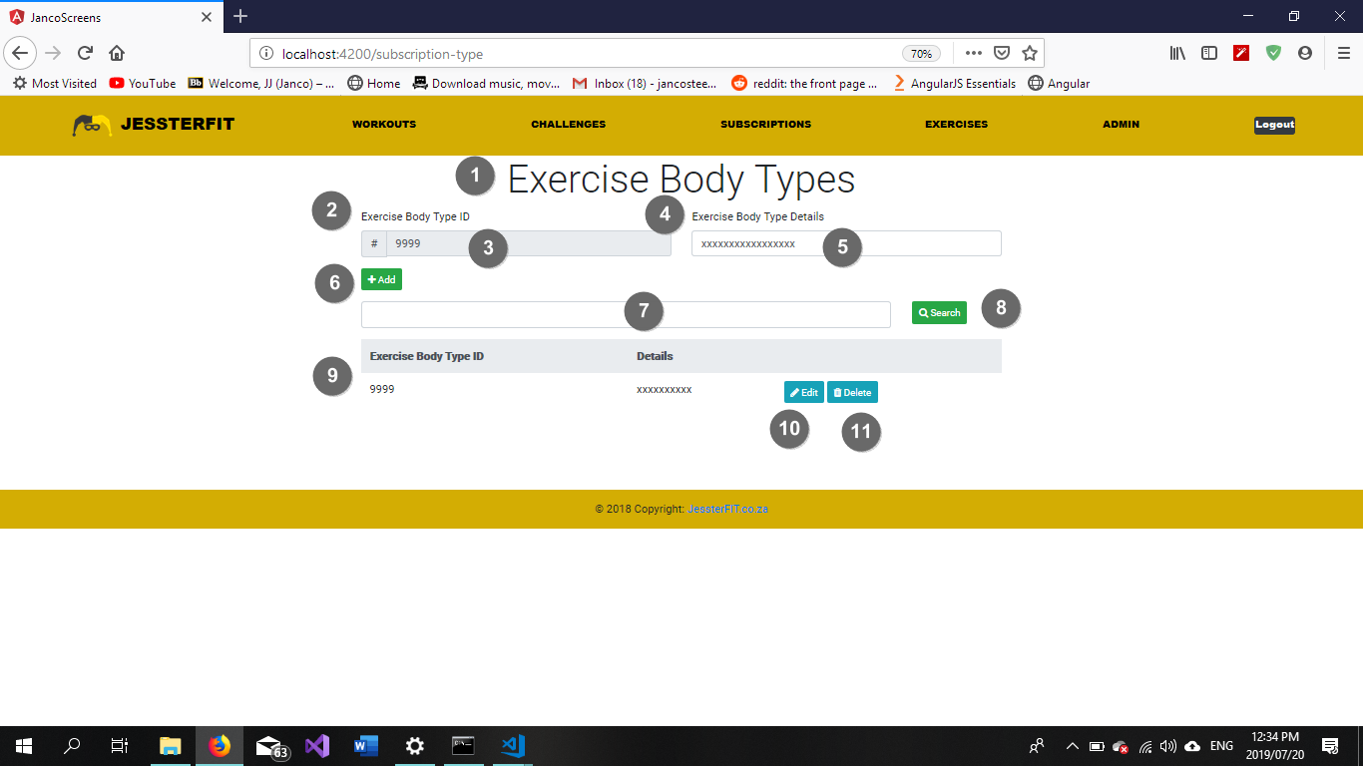

Figure 110 Add exercise body type

|  |  |  |
| --- | --- | --- |
| **Screen Name: Add Exercise Body Type** | | |
| Item Num: | Item Name: | Item Description: |
| 1 | Exercise Body Type heading | Descriptive element |
| 2 | Exercise Body Type ID label | Descriptive element |
| 3 | Exercise Body Type ID textbox | Contains Exercise Body Type ID |
| 4 | Exercise Body Type Details label | Descriptive element |
| 5 | Exercise Body Type Details textbox | Contains Exercise Body Type Details |
| 6 | Add button | Adds the record to the database |
| 7 | Search textbox | Search Criteria to be entered here |
| 8 | Search button | Clicking this button initiates the search function |
| 9 | Exercise Body Type Table | Displays all existing exercise bode type records |
| 10 | Edit button | Initiates the maintain exercise body type function |
| 11 | Delete button | Delete a record from the database |

5.6.38 Use Case 6.13 – Maintain Exercise Body Type

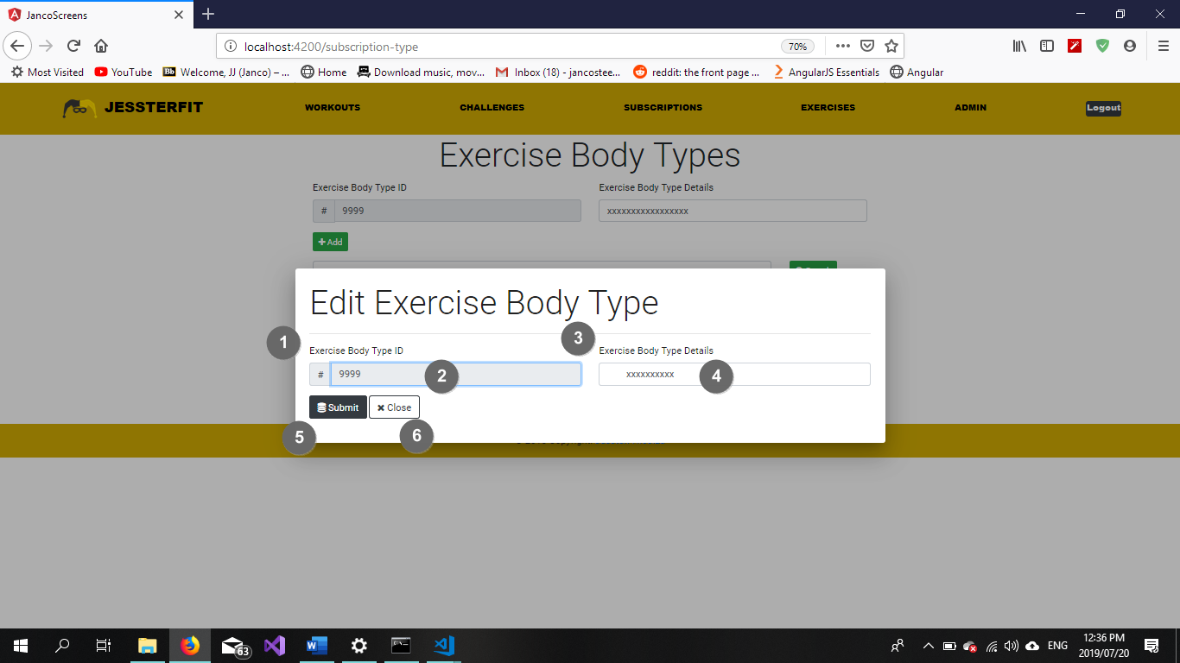

Figure 111 Maintain exercise body type

|  |  |  |
| --- | --- | --- |
| **Popup Name: Maintain Exercise Type** | | |
| Item Num: | Item Name: | Item Description: |
| 1 | Exercise Body Type ID label | Descriptive element |
| 2 | Exercise Body Type ID textbox | Contains Exercise Body Type ID |
| 3 | Exercise Body Type Details label | Descriptive element |
| 4 | Exercise Body Type Details textbox | Contains Exercise Body Type Details |
| 5 | Submit button | Update database with maintained details |
| 6 | Close button | Close pop-up and reverts any unsaved changes |

5.6.39 Add New Exercise Body Type (Success)



Figure 112 Success Message

|  |  |  |
| --- | --- | --- |
| **Popup Name: Blank Field(s) Error** | | |
| Item Num: | Item Name: | Item Description: |
| 1 | Information label | Displays information regarding current events |
| 2 | Back button | Returns user to a previous state |

5.6.40 Add New Exercise Body Type (Success)



Figure 113 Blank Field Error

|  |  |  |
| --- | --- | --- |
| **Popup Name: Blank Field(s) Error** | | |
| Item Num: | Item Name: | Item Description: |
| 1 | Information label | Displays information regarding current events |
| 2 | Back button | Returns user to a previous state |

5.6.41 Add New Exercise Body Type (Success)



Figure 114 Invalid Data Error

|  |  |  |
| --- | --- | --- |
| **Popup Name: Invalid Data Error** | | |
| Item Num: | Item Name: | Item Description: |
| 1 | Information label | Displays information regarding current events |
| 2 | Back button | Returns user to a previous state |

5.6.42 Search Exercise Body Type (No Records Found)



Figure 115 No Records Found Error

|  |  |  |
| --- | --- | --- |
| **Popup Name: No Records Found** | | |
| Item Num: | Item Name: | Item Description: |
| 1 | Information label | Displays information regarding current events |
| 2 | Back button | Navigates the user to a previous state |

5.6.43 Maintain Exercise Body Type (Delete Confirmation)



Figure 116 Delete Confirmation

|  |  |  |
| --- | --- | --- |
| **Popup Name: Confirm Delete** | | |
| Item Num: | Item Name: | Item Description: |
| 1 | Information label | Displays information regarding current events |
| 2 | Delete button | Confirms deletion of a record |
| 3 | Cancel button | Cancel the current action |

* 5.6.44 Use Case 6.20 – Add New Exercise Plan
* 5.6.45 Use Case 6.23 – Search Exercise Plan

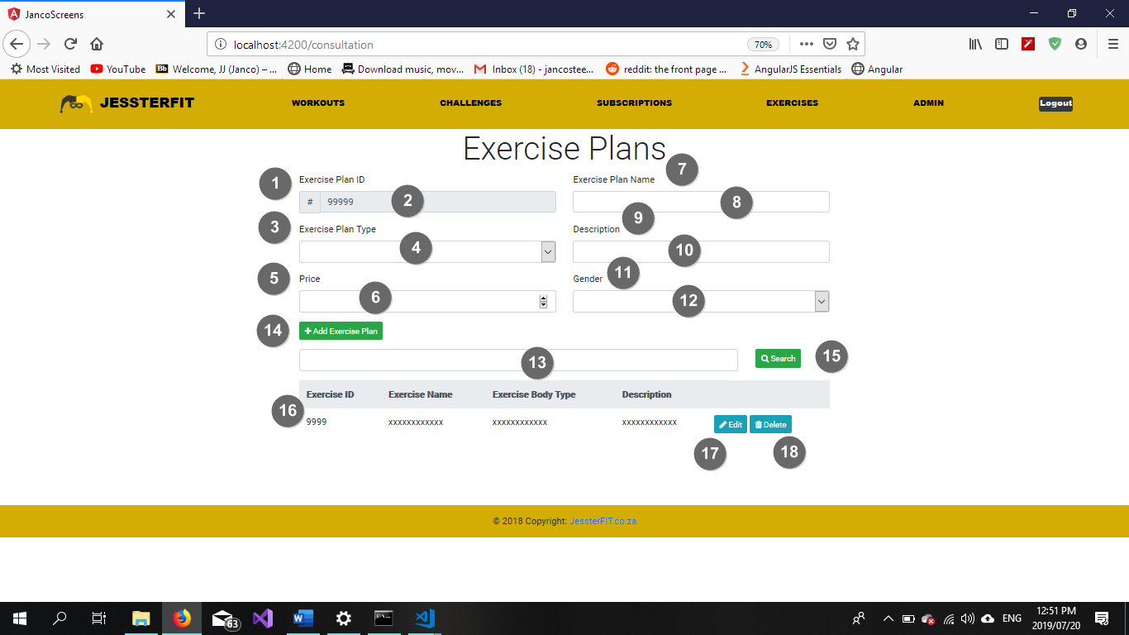

Figure 117 Add new exercise plan

|  |  |  |
| --- | --- | --- |
| **Screen Name: Add Exercise Plan** | | |
| Item Num: | Item Name: | Item Description: |
| 1 | Exercise Plan ID label | Descriptive element |
| 2 | Exercise Plan ID textbox | Contains Exercise Plan ID |
| 3 | Exercise Plan Type label | Descriptive element |
| 4 | Exercise Plan Type dropdown list | Contains Exercise Plan Type Details |
| 5 | Price label | Descriptive element |
| 6 | Price input box (type=number) | Contains Price of exercise plan |
| 7 | Exercise Plan Name label | Descriptive element |
| 8 | Exercise Plan Name textbox | Contains Exercise Plan Name |
| 9 | Description label | Descriptive element |
| 10 | Description textbox | Contains Exercise Plan Description |
| 11 | Gender label | Descriptive element |
| 12 | Gender dropdown list | Contains Gender |
| 13 | Search textbox | Search Criteria to be entered here |
| 14 | Add button | Adds the record to the database |
| 15 | Search button | Clicking this button initiates the search function |
| 16 | Exercise Plan Table | Displays all existing exercise bode type records |
| 17 | Edit button | Initiates the maintain exercise plan function |
| 18 | Delete button | Delete a record from the database |

5.6.46 Use Case 6.21 – Maintain Exercise Plan

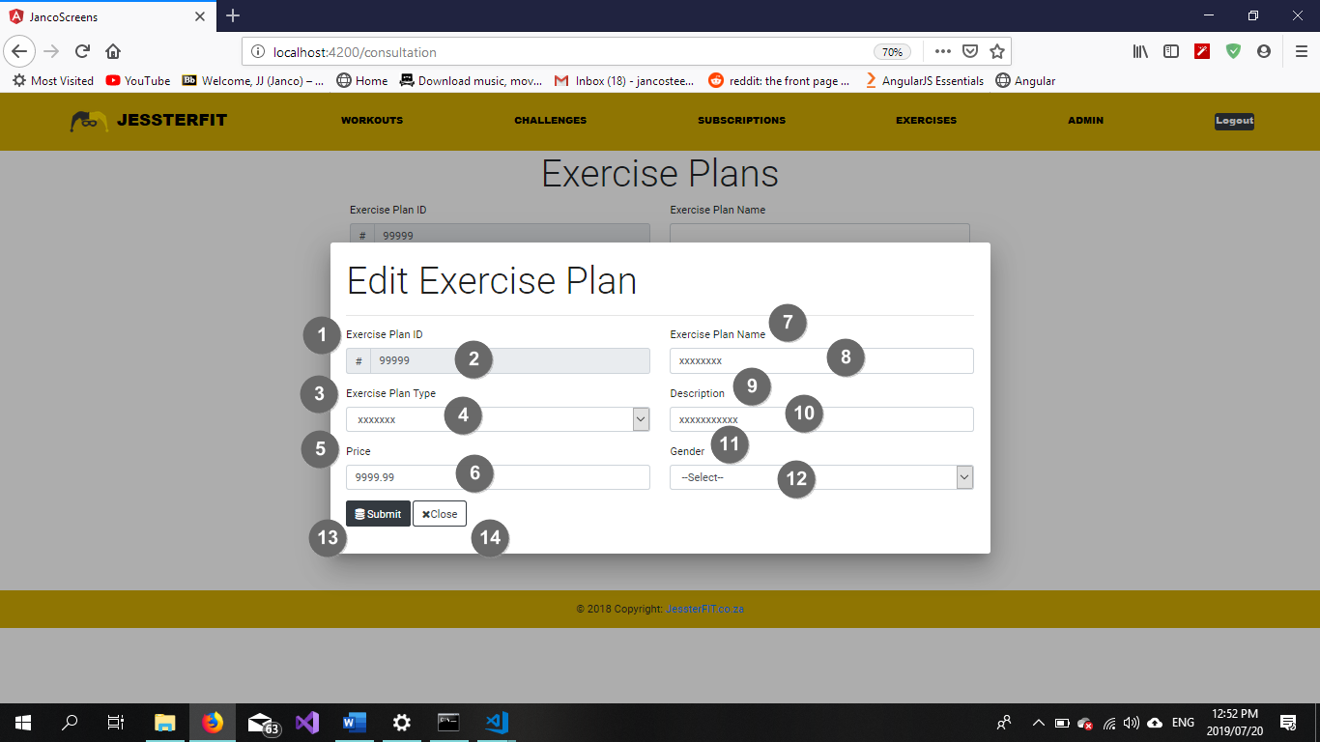

Figure 118 Maintain exercise plan

|  |  |  |
| --- | --- | --- |
| **Popup Name: Maintain Exercise Plan** | | |
| Item Num: | Item Name: | Item Description: |
| 1 | Exercise Plan ID label | Descriptive element |
| 2 | Exercise Plan ID textbox | Contains Exercise Plan ID |
| 3 | Exercise Plan Type label | Descriptive element |
| 4 | Exercise Plan Type textbox | Contains Exercise Plan Type |
| 5 | Price label | Descriptive element |
| 6 | Price input box (type=number) | Contains Exercise Plan Price |
| 7 | Exercise Plan Name label | Descriptive element |
| 8 | Exercise Plan Name textbox | Contains Exercise Plan Name |
| 9 | Description label | Descriptive element |
| 10 | Description textbox | Contains Exercise Plan Description |
| 11 | Gender label | Descriptive element |
| 12 | Gender dropdown list | Contains Gender |
| 13 | Submit button | Update database with maintained details |
| 14 | Close button | Close pop-up and reverts any unsaved changes |

5.6.47 Add New Exercise Plan (Success)



Figure 119 Success Message

|  |  |  |
| --- | --- | --- |
| **Popup Name: Blank Field(s) Error** | | |
| Item Num: | Item Name: | Item Description: |
| 1 | Information label | Displays information regarding current events |
| 2 | Back button | Returns user to a previous state |

5.6.48 Add New Exercise Plan (Blank Fields)



Figure 120 Blank Fields Error

|  |  |  |
| --- | --- | --- |
| **Popup Name: Blank Field(s) Error** | | |
| Item Num: | Item Name: | Item Description: |
| 1 | Information label | Displays information regarding current events |
| 2 | Back button | Returns user to a previous state |

5.6.49 Add New Exercise Plan (Invalid Data)



Figure 121 Invalid Data Error

|  |  |  |
| --- | --- | --- |
| **Popup Name: Invalid Data Error** | | |
| Item Num: | Item Name: | Item Description: |
| 1 | Information label | Displays information regarding current events |
| 2 | Back button | Returns user to a previous state |

5.6.50 Maintain Exercise Plan (Delete Confirmation)



Figure 122 Delete Confirmation

|  |  |  |
| --- | --- | --- |
| **Popup Name: Confirm Delete** | | |
| Item Num: | Item Name: | Item Description: |
| 1 | Information label | Displays information regarding current events |
| 2 | Delete button | Confirms deletion of a record |
| 3 | Cancel button | Cancel the current action |

5.6.51 Search Exercise Plan (No Records Found)



Figure 123 No Records Found Error

|  |  |  |
| --- | --- | --- |
| **Popup Name: No Records Found** | | |
| Item Num: | Item Name: | Item Description: |
| 1 | Information label | Displays information regarding current events |
| 2 | Back button | Navigates the user to a previous state |